**BANKING**

**AND**

**FINANCE PROJECT**

Submission by : Pallavi

Submitted to : Vikul

Date of submission: 06-12-24



## Banking and Finance Project

The project involves creating a fully automated pipeline with Terraform, Jenkins, Docker, Ansible, Prometheus, and Grafana for monitoring.

✓ Git - For version control for tracking changes in the code files

✓ Maven – For Continuous Build

✓ Jenkins - For continuous integration and continuous deployment

✓ Docker - For deploying containerized applications

✓ Ansible - Configuration management tools

✓ Terraform - For creation of infrastructure.

✓ Prometheus and Grafana – For Automated Monitoring and Report Visualization

**FinanceMe** project code is attached below

**https://github.com/StarAgileDevOpsTraining/star-agile-banking-finance.git**

### ****Step 1: Create a VM and Install Terraform****

**1.Launch a VM (Ubuntu 22.04) in AWS**:

1. Instance Type: t2.micro
2. Security Group: Allow **All traffic (Anywhere)**.

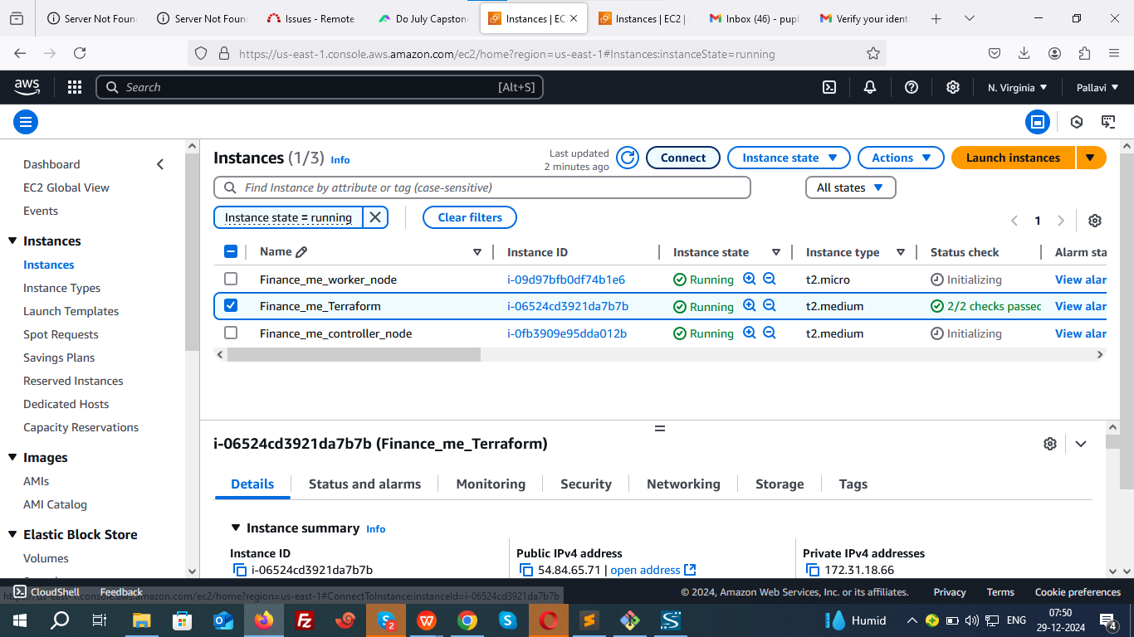

**2. Connect to the VM**:

Use SSH to connect.

EC2>>Instances>>i00678f747e2d88f5e>>Connect\_to\_instance

ssh -i "aws\_key\_pair.pem" [ubuntu@ec2-54-84-65-71.compute-1.amazonaws.com](mailto:ubuntu@ec2-54-84-65-71.compute-1.amazonaws.com)

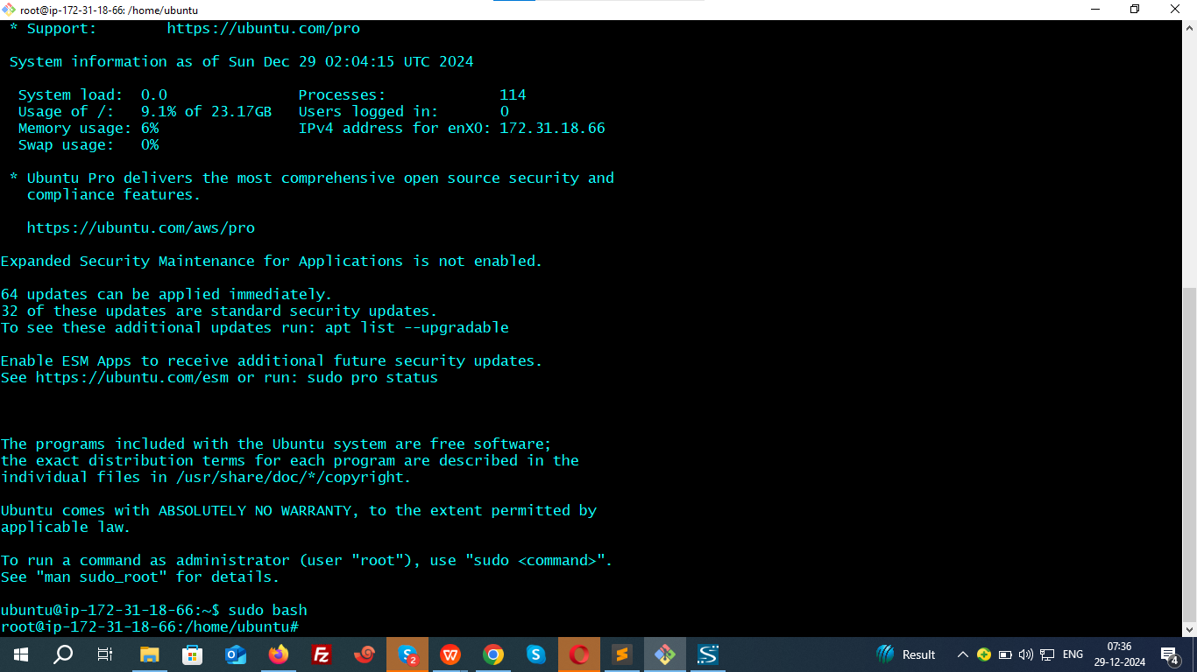

**3. Install Terraform**:

wget -O- https://apt.releases.hashicorp.com/gpg | sudo gpg --dearmor -o /usr/share/keyrings/hashicorp-archive-keyring.gpg

echo "deb [signed-by=/usr/share/keyrings/hashicorp-archive-keyring.gpg] https://apt.releases.hashicorp.com $(lsb\_release -cs) main" | sudo tee /etc/apt/sources.list.d/hashicorp.list

sudo apt update && sudo apt install terraform

Verify installation.

terraform --version

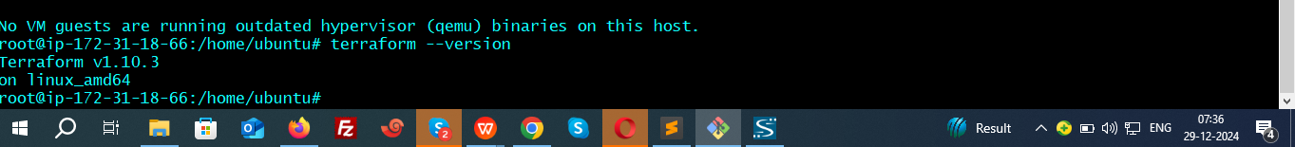

**4.Establishing a connection between Terraform and AWS**.

Create AWS Access Key and Secret Key.

Creating an Access Key and Secret Key in AWS is a crucial step to allow Terraform to authenticate and interact with AWS resources.

1. **Create an AWS IAM User with Administrator Access**

**Login to AWS Management Console.**

**Navigate to IAM > Users.**

**Create a New User:** Enable **Programmatic Access**.

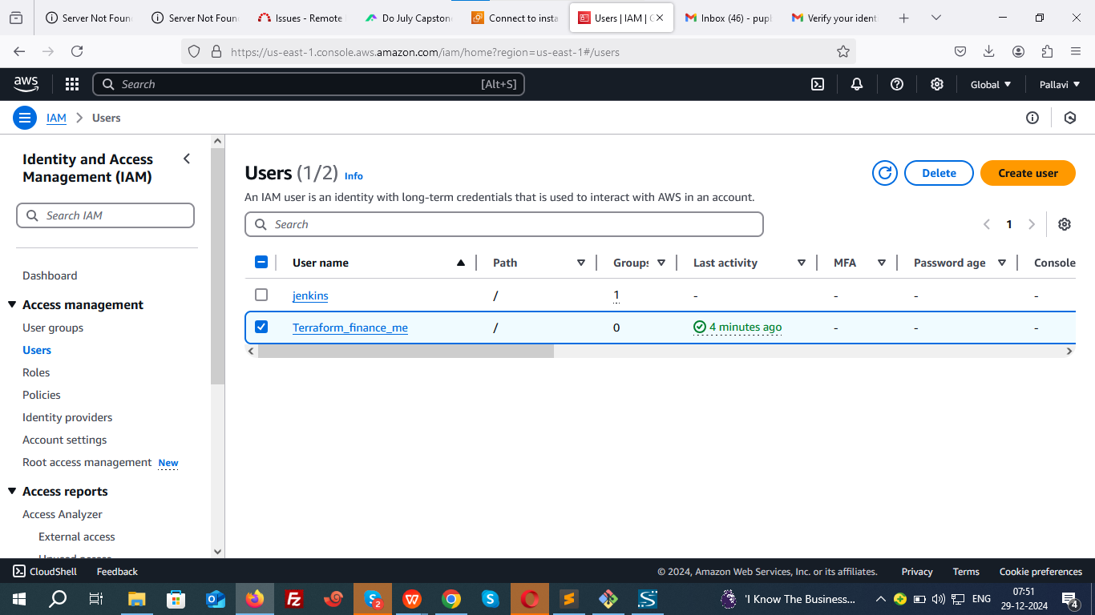

**Attach a Policy:**

Attach the **AdministratorAccess** policy to the user.

**Generate Access Keys:**

Save the **Access Key ID** and **Secret Access Key** securely (you will need these).

1. **Configure AWS CLI**

**Install AWS CLI (if not installed):**

sudo apt install awscli

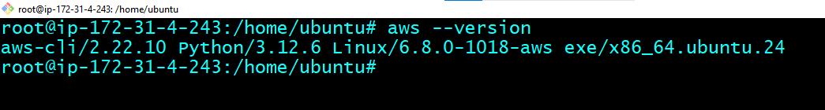

aws configure

Enter the **Access Key ID**, **Secret Access Key**, region (e.g., us-east-1), and output

format (json).

**Verify AWS Configuration:**

**aws --version**



cat ~/.aws/credentials



**5.Write Terraform Configuration File**:

**Create dedicated directory and navigate.**

mkdir finance\_me && cd finance\_me

vim aws\_infra.tf

Paste the provided Terraform configuration code to create an EC2 instance, VPC, Subnet, Security Group, and install Ansible.

provider "aws" {

region = "us-east-1"

shared\_credentials\_files = ["~/.aws/credentials"]

}

resource "tls\_private\_key" "mykey" {

algorithm = "RSA"

}

resource "aws\_key\_pair" "aws\_key" {

key\_name = "web-key"

public\_key = tls\_private\_key.mykey.public\_key\_openssh

provisioner "local-exec" {

command = "echo '${tls\_private\_key.mykey.private\_key\_openssh}' > ./web-key.pem"

}

}

resource "aws\_vpc" "sl-vpc" {

cidr\_block = "10.0.0.0/16"

tags = {

Name = "sl-vpc"

}

}

resource "aws\_subnet" "subnet-1" {

vpc\_id = aws\_vpc.sl-vpc.id

cidr\_block = "10.0.1.0/24"

depends\_on = [aws\_vpc.sl-vpc]

map\_public\_ip\_on\_launch = true

tags = {

Name = "sl-subnet"

}

}

resource "aws\_route\_table" "sl-route-table" {

vpc\_id = aws\_vpc.sl-vpc.id

tags = {

Name = "sl-route-table"

}

}

resource "aws\_route\_table\_association" "a" {

subnet\_id = aws\_subnet.subnet-1.id

route\_table\_id = aws\_route\_table.sl-route-table.id

}

resource "aws\_internet\_gateway" "gw" {

vpc\_id = aws\_vpc.sl-vpc.id

depends\_on = [aws\_vpc.sl-vpc]

tags = {

Name = "sl-gw"

}

}

resource "aws\_route" "sl-route" {

route\_table\_id = aws\_route\_table.sl-route-table.id

destination\_cidr\_block = "0.0.0.0/0"

gateway\_id = aws\_internet\_gateway.gw.id

}

variable "sg\_ports" {

type = list(number)

default = [8080, 80, 22, 443]

}

resource "aws\_security\_group" "sl-sg" {

name = "sg\_rule"

vpc\_id = aws\_vpc.sl-vpc.id

dynamic "ingress" {

for\_each = var.sg\_ports

iterator = port

content {

from\_port = port.value

to\_port = port.value

protocol = "tcp"

cidr\_blocks = ["0.0.0.0/0"]

}

}

egress {

from\_port = 0

to\_port = 0

protocol = "-1"

cidr\_blocks = ["0.0.0.0/0"]

}

}

resource "aws\_instance" "myec2" {

ami = "ami-005fc0f236362e99f"

instance\_type = "t2.medium"

key\_name = "web-key"

subnet\_id = aws\_subnet.subnet-1.id

security\_groups = [

aws\_security\_group.sl-sg.id

]

tags = {

Name = "Finance\_me"

}

provisioner "remote-exec" {

connection {

type = "ssh"

user = "ubuntu"

private\_key = tls\_private\_key.mykey.private\_key\_pem

host = self.public\_ip

}

inline = [

"sudo apt update",

"sudo apt install software-properties-common",

"sudo add-apt-repository --yes --update ppa:ansible/ansible",

"sudo apt install ansible -y"

]

}

}

**Initialize and Apply Terraform**:

terraform init - Prepares the working directory for Terraform by downloading plugins and setting up the backend.

terraform validate - Checks for syntax errors and configuration validity.

terraform plan - Generates and displays an execution plan without making changes.

terraform apply --auto-approve - Executes the plan and creates or updates infrastructure without requiring manual confirmation.

Instance has been created in us-east-1

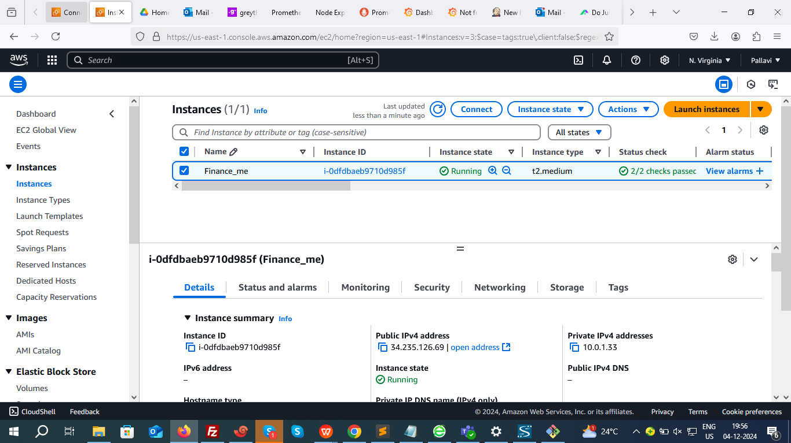

****Step 2:**** Ceate connection between Ansible controller and worker

#### ****On the Controller Node****

**1.** Verify **Ansible** installation

ansible --version

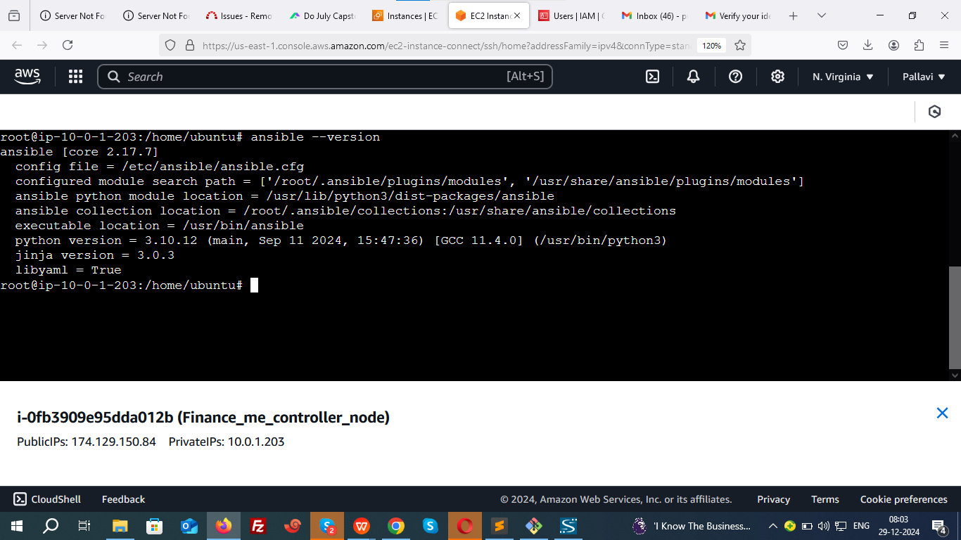

**2. Become a root user and create a New User (**ansiuser**)**

--> Add a new user named ansiuser

sudo useradd ansiuser

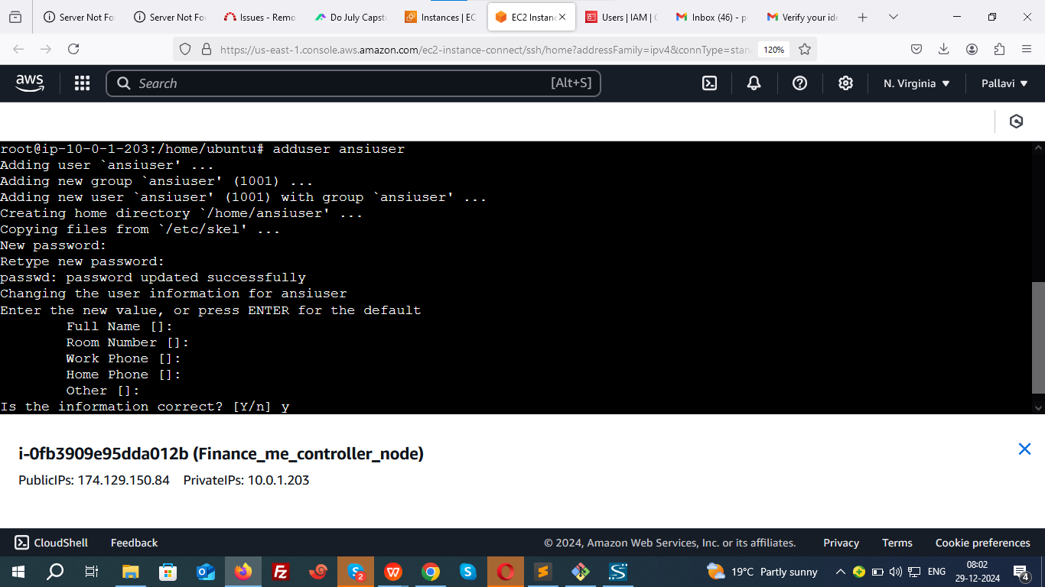

**3. Grant Root Privileges to** ansiuser

--> Edit the sudoers file

sudo vim /etc/sudoers

Add the following line at the end of the file:

plaintext

ansiuser ALL=(ALL) NOPASSWD:ALL

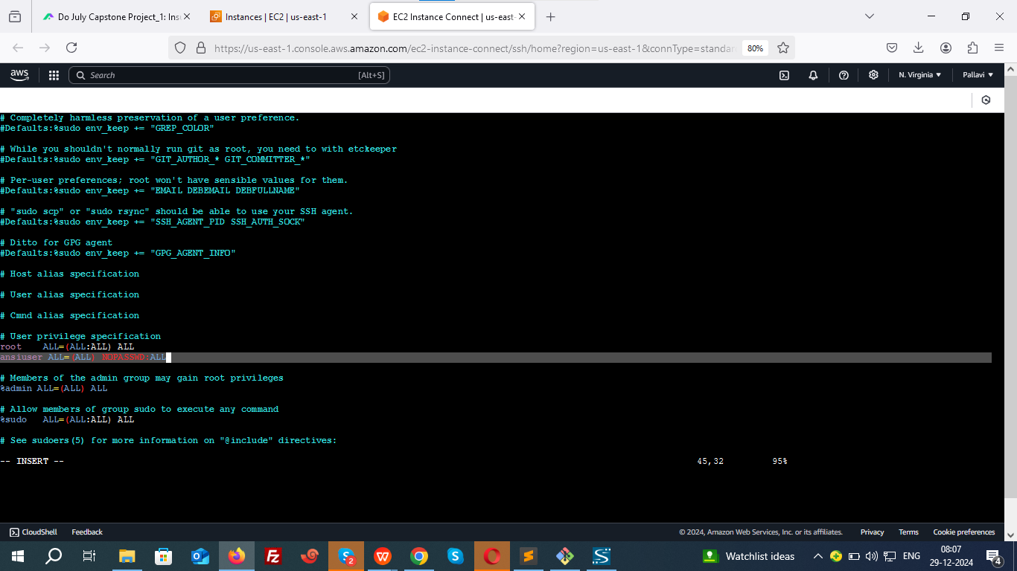

**4. Switch to ansiuserand Generate SSH Key**

--> Switch to the new user

sudo su - ansiuser

--> Generate an SSH key pair

ssh-keygen--> Press Enter for all prompts to create the key with default settings

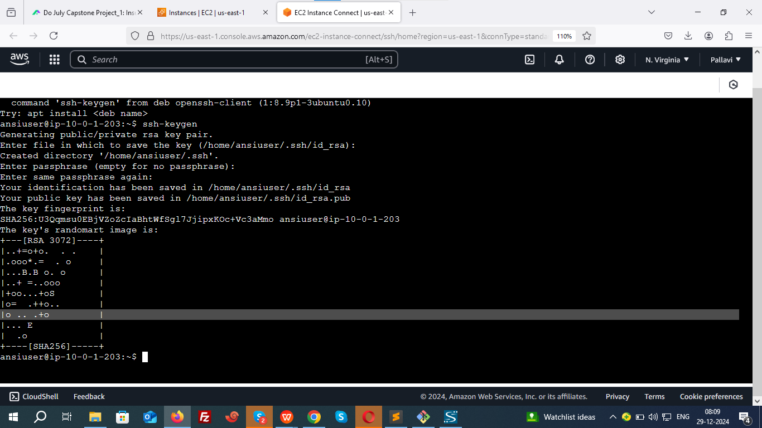

--> Display the public key cat /home/ansiuser/.ssh/id\_rsa.pub

Copy the output of the public key for use on the worker node.

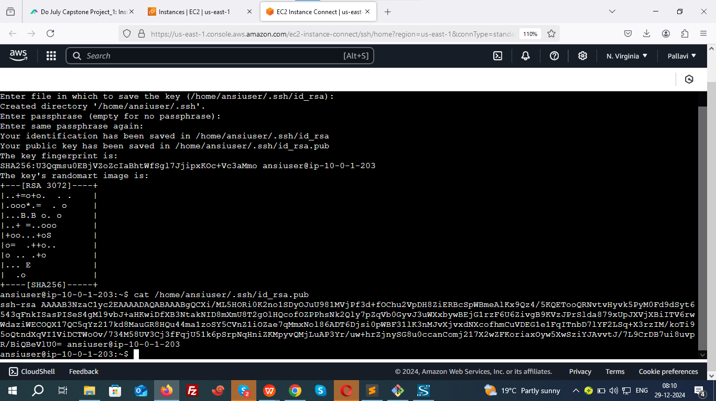

#### ****On the Managed Host (Ansible worker Node)****

**1. Create the User (**ansiuser**)**

--> Add a new user named ansiuser

sudo useradd ansiuser

**2. Grant Root Privileges to** ansiuser

--> Edit the sudoers file

sudo vim /etc/sudoers

Add the following line at the end of the file:

plaintext

ansiuser ALL=(ALL) NOPASSWD:ALL

**3. Create** .ssh **Directory and Authorize the Public Key**

--> Switch to the new user

sudo su - ansiuser

--> Create the .ssh directory with appropriate permissions

mkdir -m 700 /home/ansiuser/.ssh

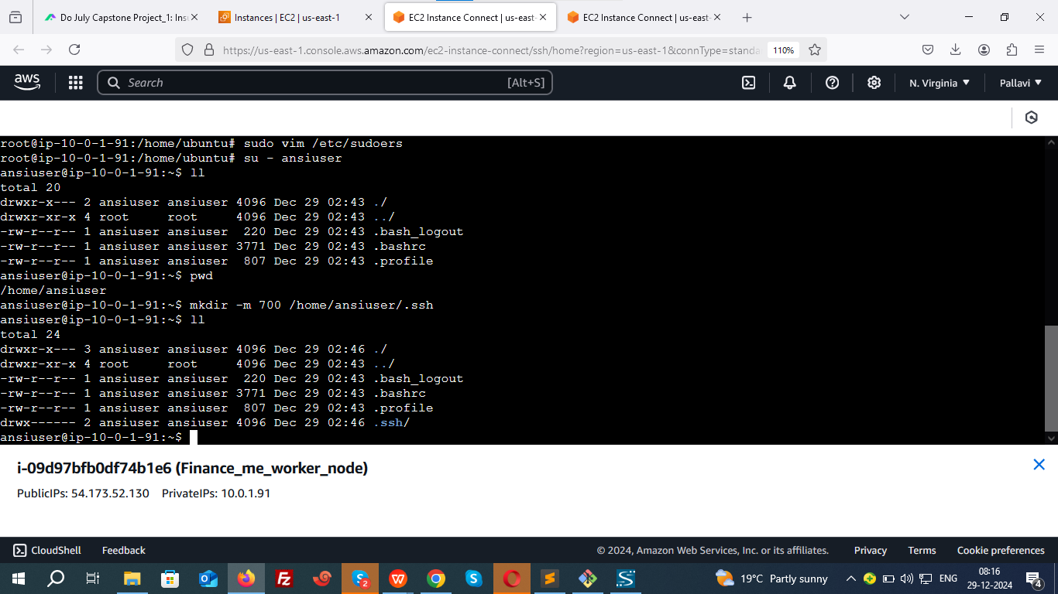

--> Create the authorized\_keys file and paste the public key

echo "<public\_key>" > /home/<username>/.ssh/authorized\_keys

echo "ssh-ed25519 AAAAC3NzaC1lZDI1NTE5AAAAICnw44aTtiOfc+uCRTfVccNzD/9F6ZPwpkLV+iIiFKNY ansiuser@ip-172-31-84-10" > /home/ansiuser/.ssh/authorized\_keys

--> Set proper permissions for the authorized\_keys file

chmod 600 /home/ansiuser/.ssh/authorized\_keys

#### ****Verify SSH Access****

From the **controller node**, test SSH access to the managed node as ansiuser:

ssh ansiuser@<host\_private\_IP>

If configured correctly, you will be able to log in without a password.

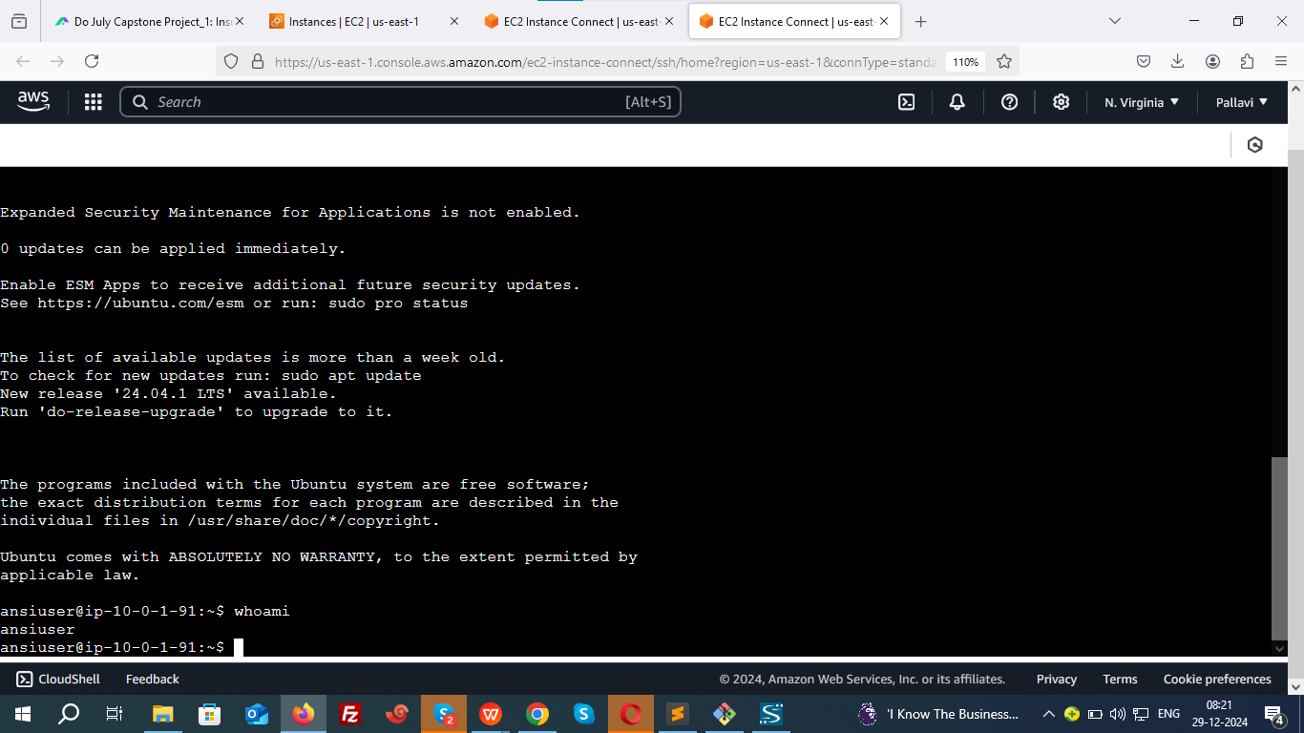

#### ****Additional Steps for Ansible Inventory and Ping Test****

By default the inventory file for ansible will be available at /etc/ansible/

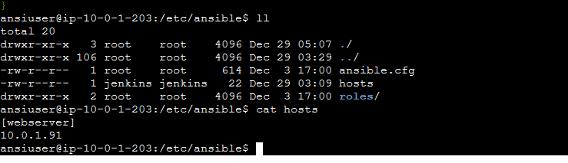

Press i to insert below data in file called hosts

[webserver]

10.0.1.91

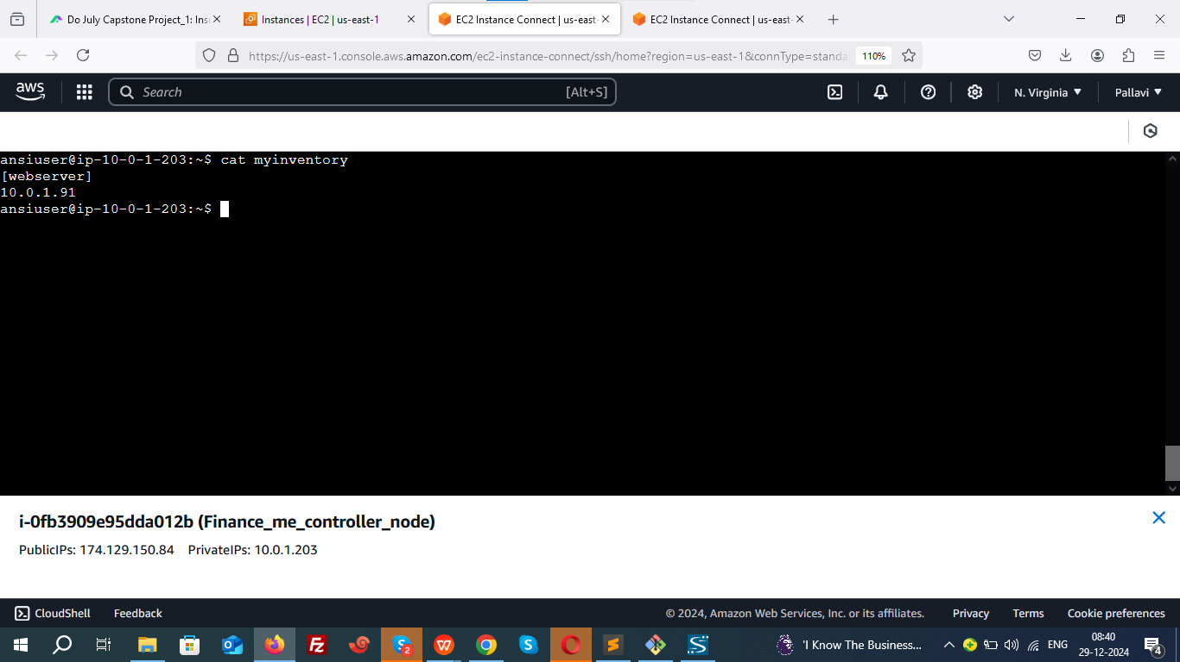

Save the file.

**Test Ansible Connection**:

Execute below Ad Hoc command

ansible -i <inventory\_file\_name> <target\_host\_group\_name> -m <module\_name>

ansible -i myinventory webserver -m ping

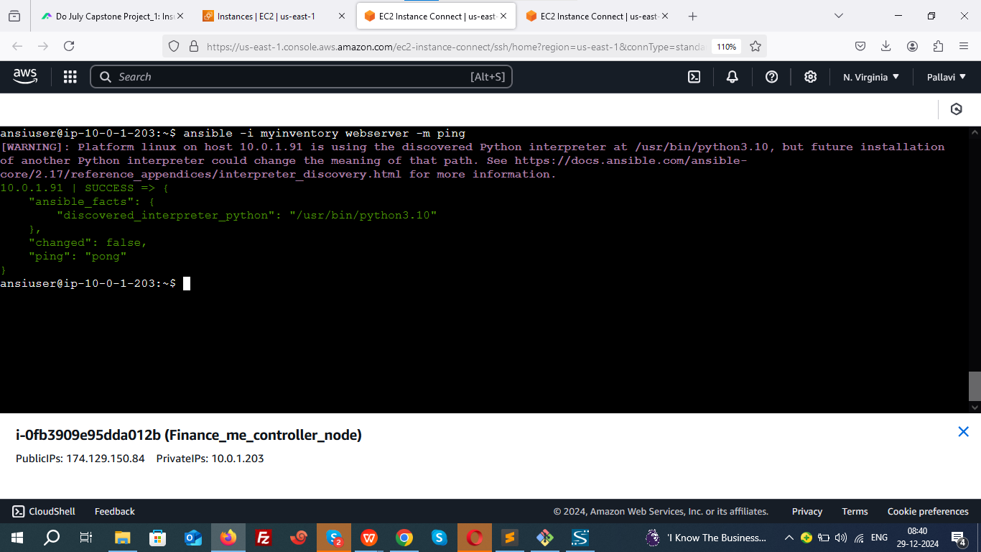

· SUCCESS: Indicates the host was reachable.

· ping: "pong": Confirms successful communication.

**Install Java , Jenkins, git and docker Using Ansible Playbook**:

**Add Jenkins key and repo manually.**

**ADD GPG KEY:**

sudo wget -O /usr/share/keyrings/jenkins-keyring.asc \

https://pkg.jenkins.io/debian-stable/jenkins.io-2023.key

**ADD Jenkins repository:**

echo "deb [signed-by=/usr/share/keyrings/jenkins-keyring.asc]" \https://pkg.jenkins.io/debian-stable binary/ | sudo tee \

/etc/apt/sources.list.d/jenkins.list > /dev/null

Create an Ansible playbook:

vim finance\_me.yml

Add the following:

- name: Install and set up devops tools

hosts: localhost

become: true

tasks:

- name: Update the apt repo

command: apt-get update

- name: Install multiple packages

package: name={{item}} state=present

loop:

- git

- docker.io

- openjdk-17-jdk

- name: update apt-repo

command: sudo apt-get update

- name: install jenkins

command: sudo apt-get install jenkins -y

- name: start Jenkins and docker service

service: name={{item}} state=started

loop:

- jenkins

- docker

Run the playbook:

ansible-playbook finance\_me.yml

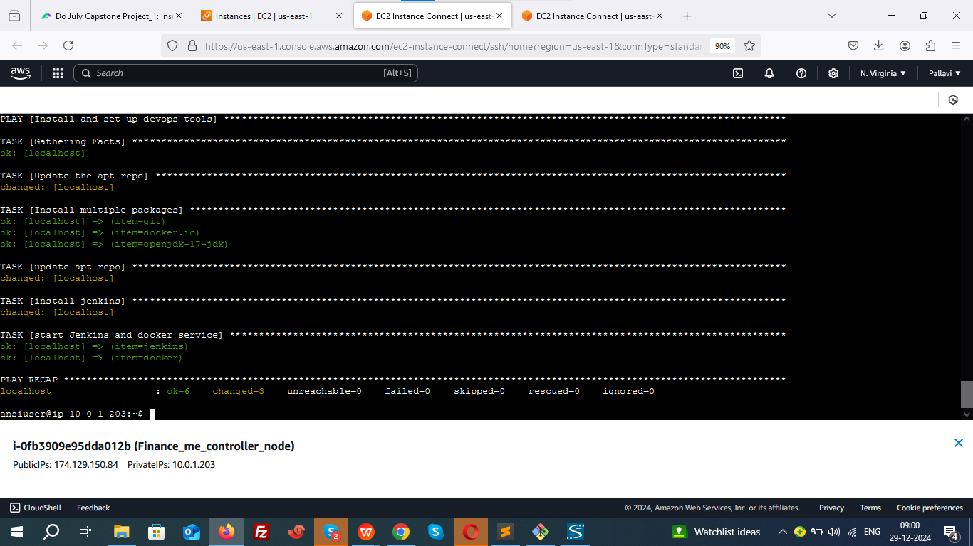

Verify installations.

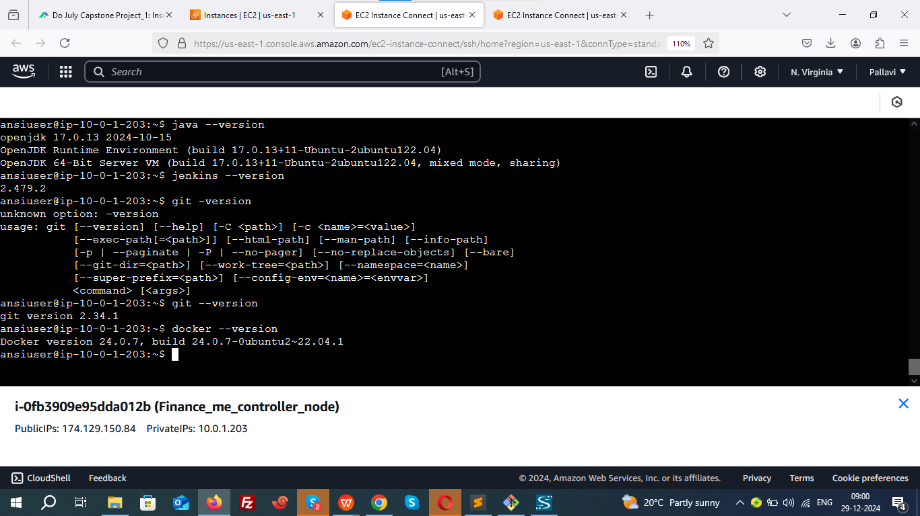

**Verify:**

sudo systemctl status jenkins

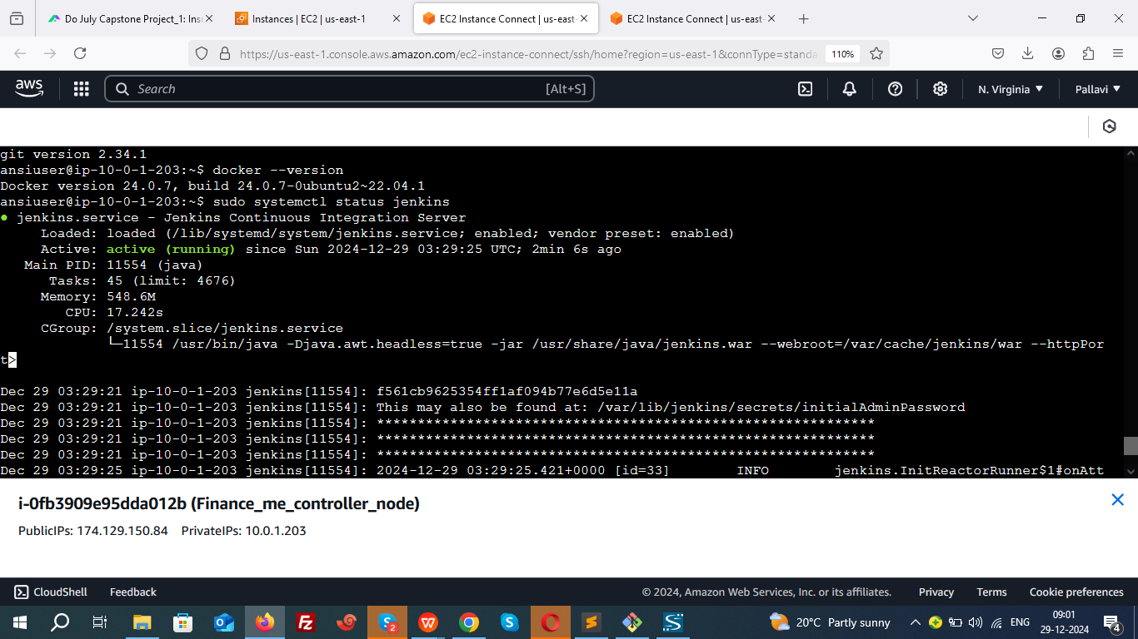

1. **Now access to the jenkins dashboard using below url:**

http://174.129.150.84:8080

Default port: 8080.

1. **Set up plugins and admin user.**

cat /var/lib/jenkins/secrets/initialAdminPassword

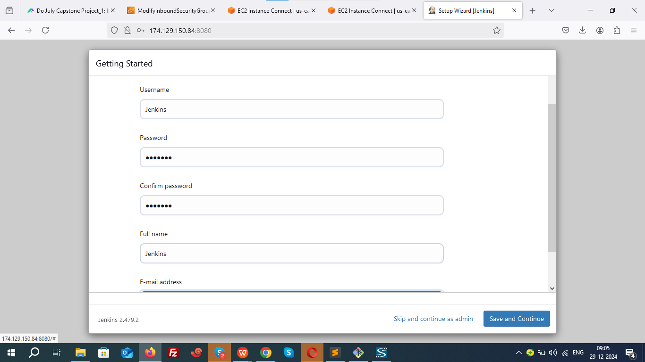

1. **Configure Maven**:

Go to **Manage Jenkins > Global Tool Configuration**.

Add Maven and set it up.

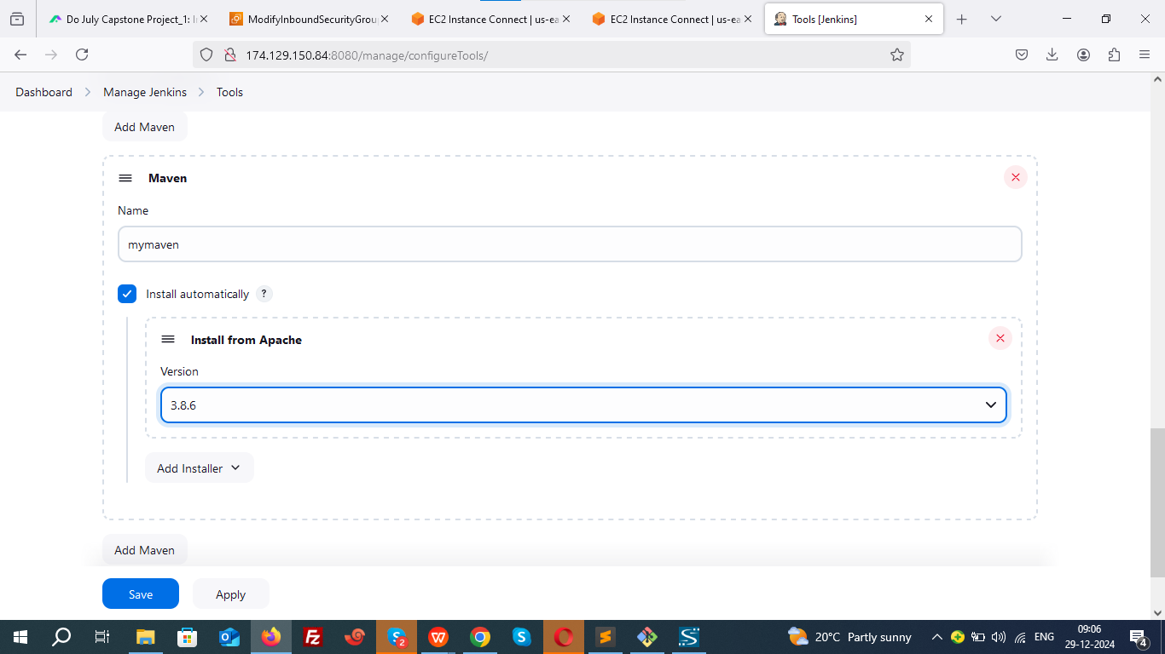--

Make sure to give same name for maven in pipeline.

1. **Create Pipeline**:

**Points to be noted:**

In source code go to src/main/resources/application.properties

Check server port

docker run -d -p 8081:8081 myproject1:$BUILD\_NUMBER

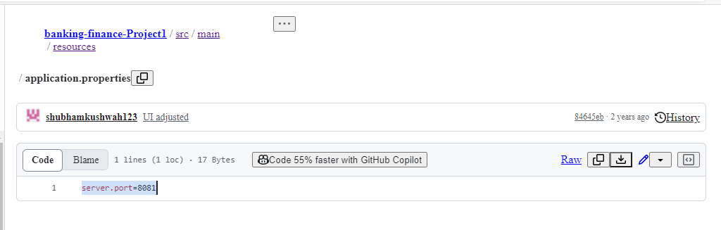

1. **Map the internal container port (8081) to an external port on your host machine**

In pipeline:  
docker run -d -p 8081:8081 myproject1:$BUILD\_NUMBER

1. **Enable 8081 in your ec2 security groups.**
2. **Check and Configure Docker Hub Credentials in Jenkins**

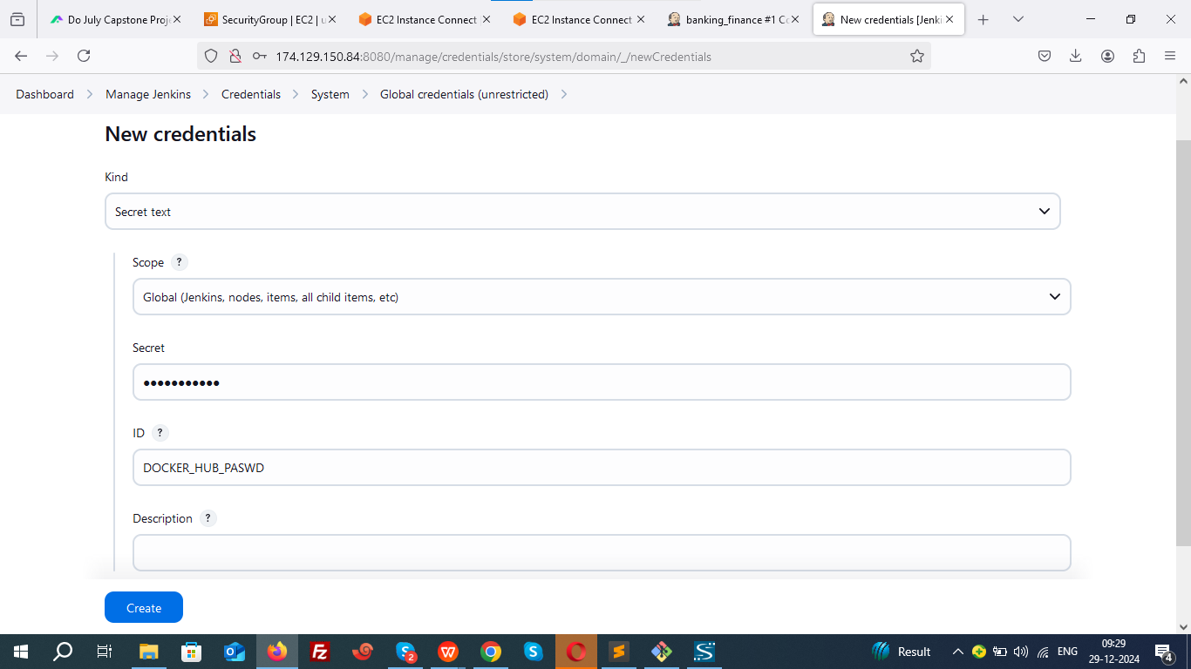

1. **Install Ansible plugin.**
2. **Add ansiuser credential In Jenkins**

**(In Jenkins we have created ssh key for ansiuser)**

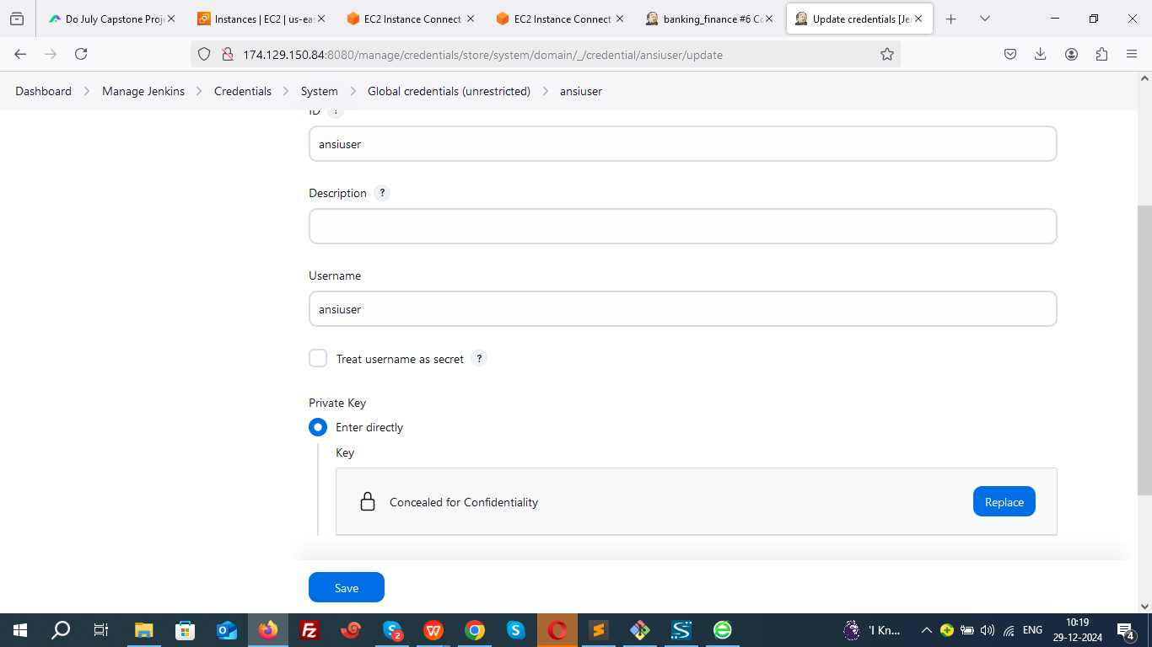

1. **We are going to run playbook which is already available on git hub.**

ansible-playbook.yml

Just edit image name

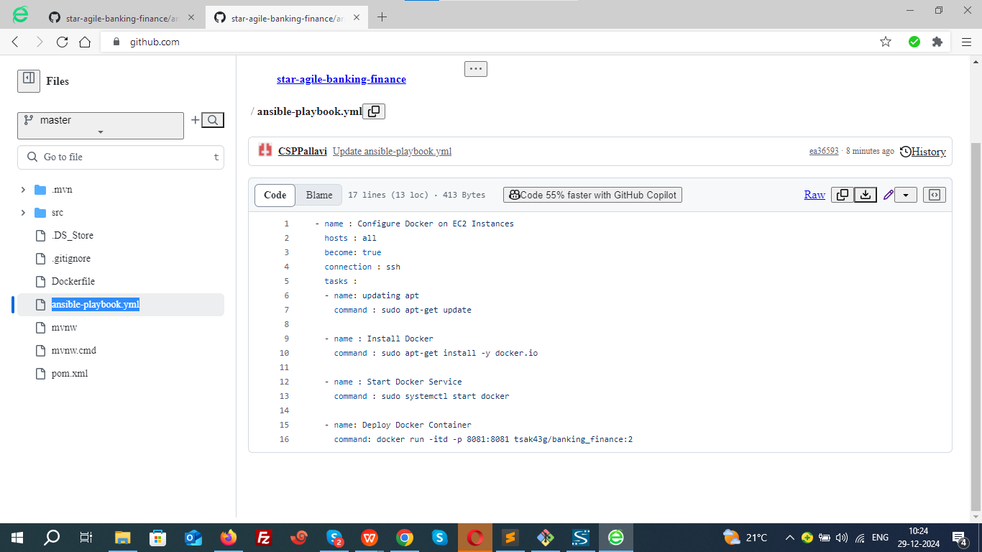

Navigate to **New Item > Pipeline**.

pipeline {

agent any

tools {

maven 'mymaven'

}

stages {

stage('Clone Repo') {

steps {

git 'https://github.com/CSPPallavi/star-agile-banking-finance.git'

}

}

stage('Test Code') {

steps {

sh 'mvn test'

}

}

stage('Build Code') {

steps {

sh 'mvn package'

}

}

stage('Build Image') {

steps {

sh 'docker build -t banking\_finance:$BUILD\_NUMBER .'

}

}

stage('Push the Image to DockerHub') {

steps {

withCredentials([string(credentialsId: 'DOCKER\_HUB\_PASWD', variable: 'DOCKER\_HUB\_PASWD')]) {

sh 'docker login -u tsak43g -p ${DOCKER\_HUB\_PASWD}'

}

sh 'docker tag banking\_finance:$BUILD\_NUMBER tsak43g/banking\_finance:$BUILD\_NUMBER'

sh 'docker push tsak43g/banking\_finance:$BUILD\_NUMBER'

}

}

stage('Deploy to Worker Server') {

steps {

ansiblePlaybook(

credentialsId: 'ansiuser', // Use the credentials ID for the SSH private key required by Ansible

playbook: 'ansible-playbook.yml',

inventory: '/etc/ansible/hosts',

disableHostKeyChecking: true,

become: true

)

}

}

}

}

**Befor building the job allow Jenkins to Run Docker Commands**:

chmod -R 777 /var/run/docker.sock

**Build the job successfully.**

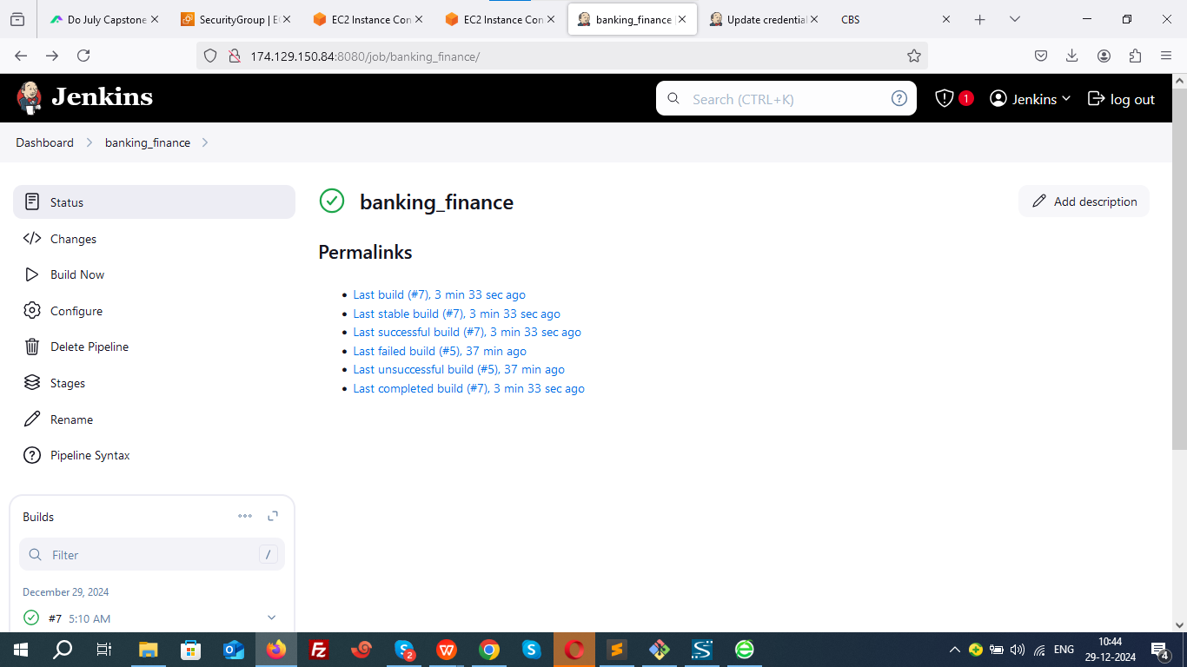

**Verify docker image and container.**

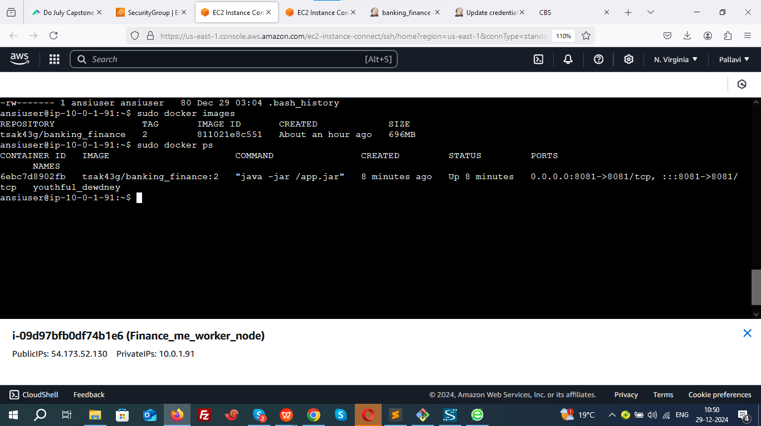

**Access the container**

**workernode public ip**

**<http://54.173.52.130:8081/>**



**STEP 4: WEBHOOK CONFIGURATION:**

Go to your Jenkins dashboard and add build trigger- **GitHub hook trigger for GITScm polling**

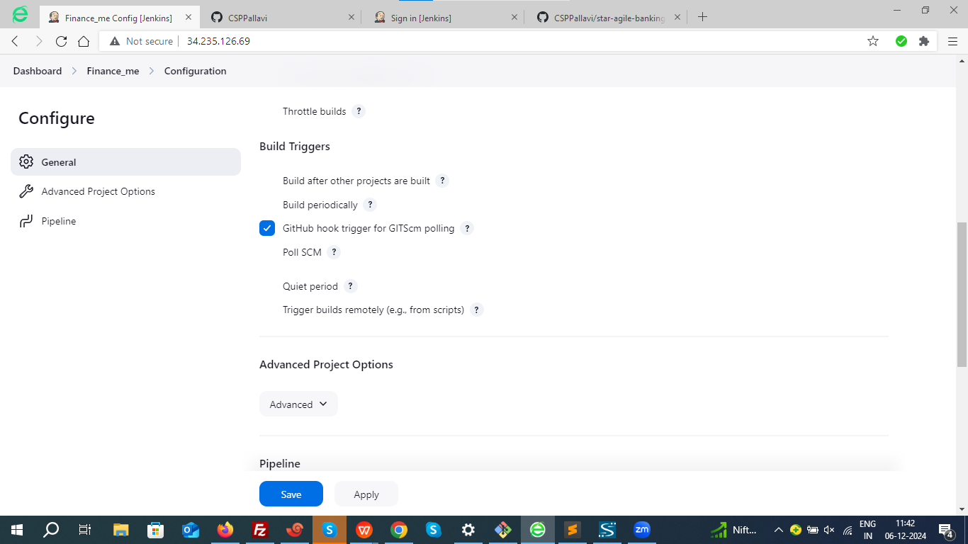

Configuring a webhook in Git is a crucial step to enable automated actions, such as triggering a CI/CD pipeline in Jenkins or notifying an application about repository events.

### ****Step 1: Open Your Repository Settings****

1. Navigate to the repository where you want to configure the webhook.

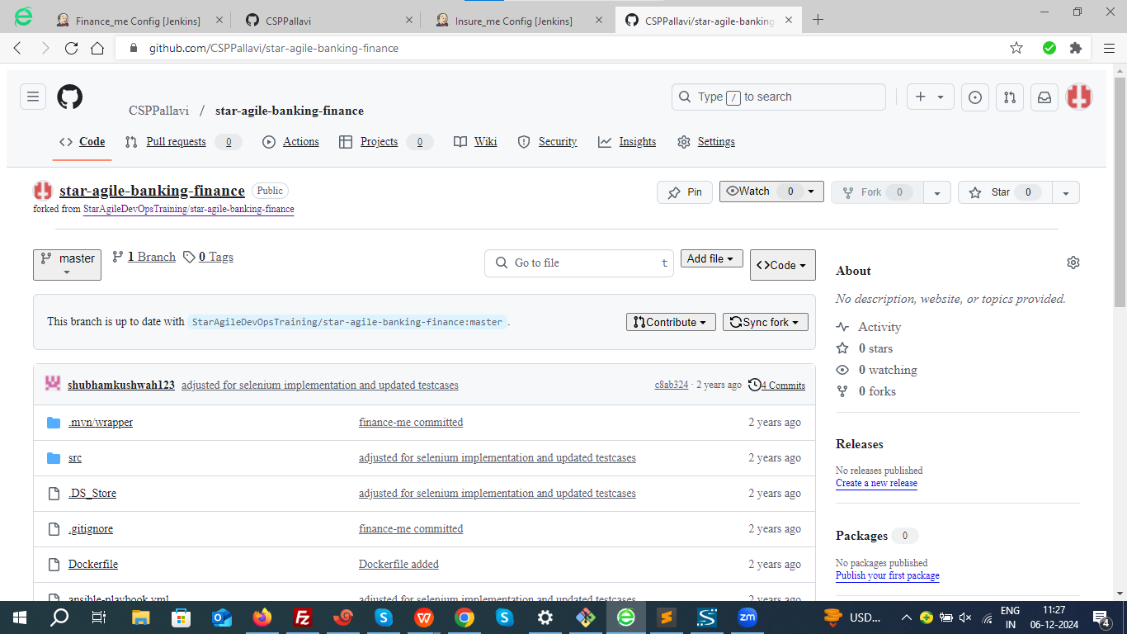

### ****Step 2: Find the Webhooks Section****

Go to **Repository Settings** > **Webhooks**.

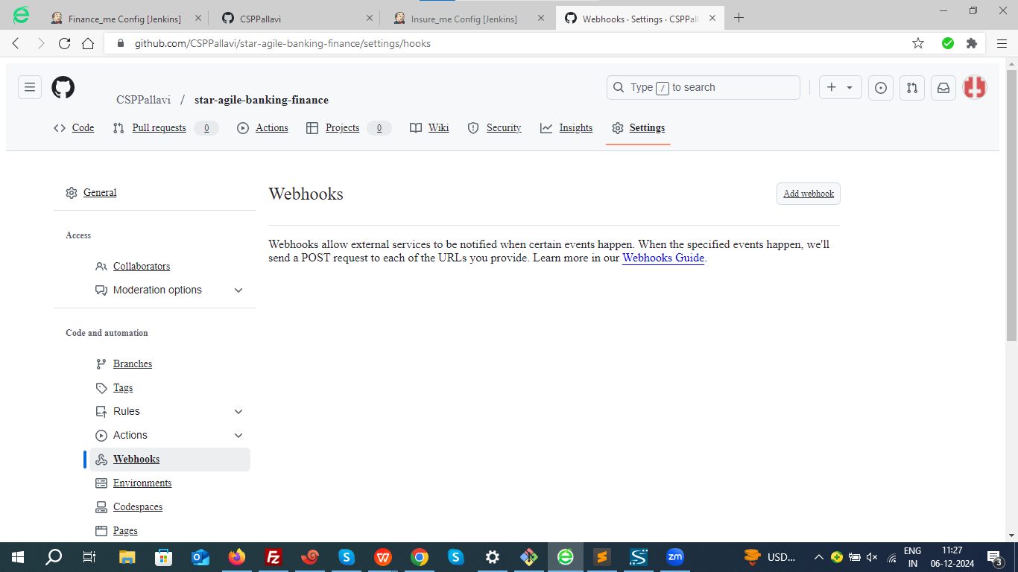

### ****Step 3: Add a New Webhook****

Fill in the webhook details:

**Payload URL**:

· This is the endpoint that will receive the webhook payload.

· <http://<Jenkins-URL>/github-webhook/>

[http://174.129.150.84:8080/github-webhook/](http://3.110.193.218:8080/github-webhook/)

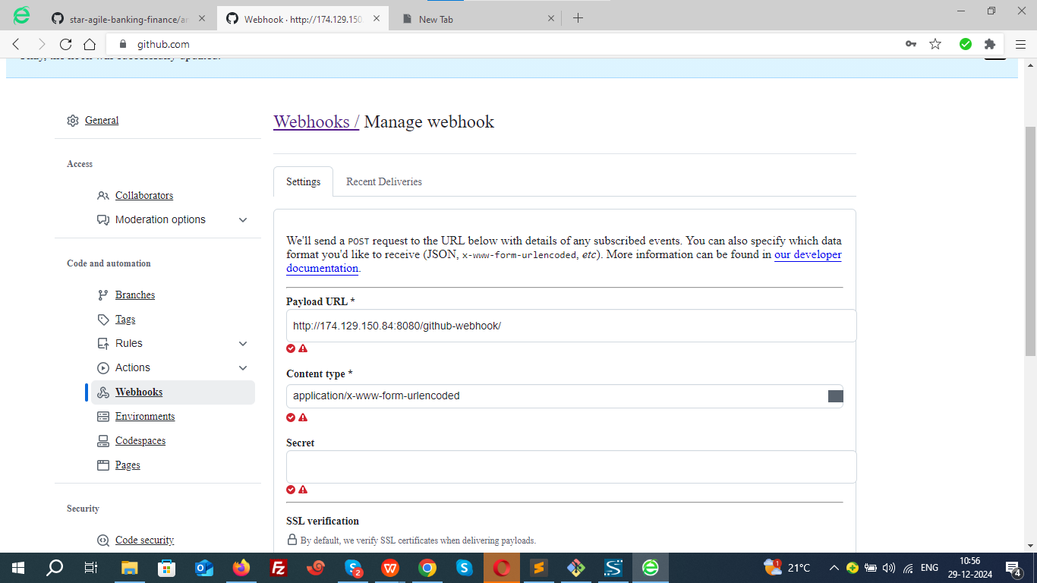

### ****Step 4 : Commit changes and save.****

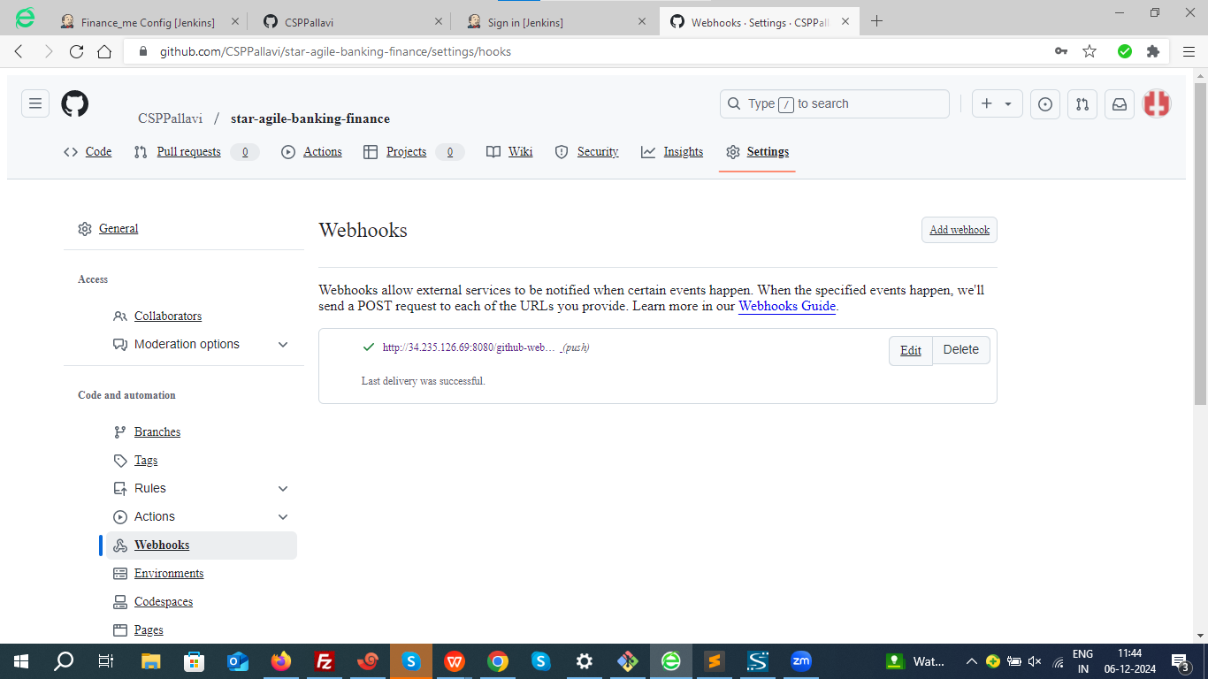

### ****Step 5 : Testing webhook.****

Lets make changes in thehome page of the application.



Let’s make changes in welcome page where it says **Doorstep Banking Services.**

Let’s change this to **[Customer Banking Services](https://www.hdfcbank.com/personal/resources/ways-to-bank/banking-in-person/doorstep-banking)**

Go to index.html path in your git hub

**star-agile-insurance-project/src/main/resources/static**

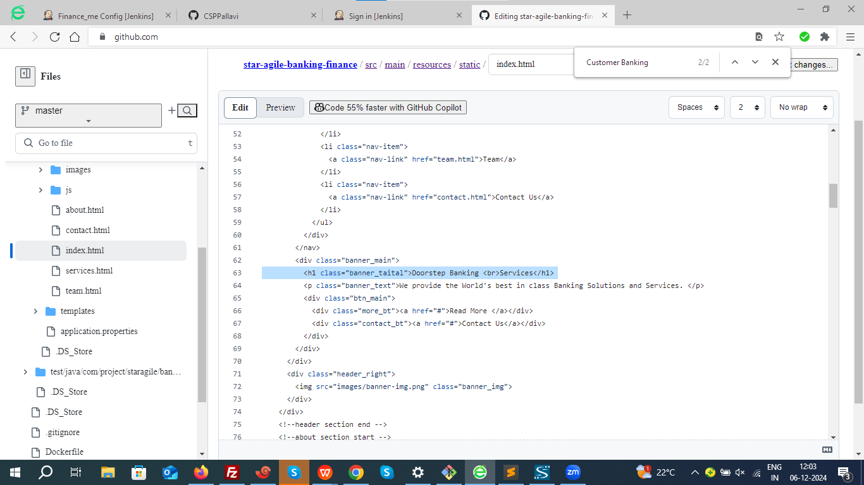

Now commit the changes.

Immidiately a new buils shoud trigger.

In the below snapshot it is evident a new build 8 has been triggered.

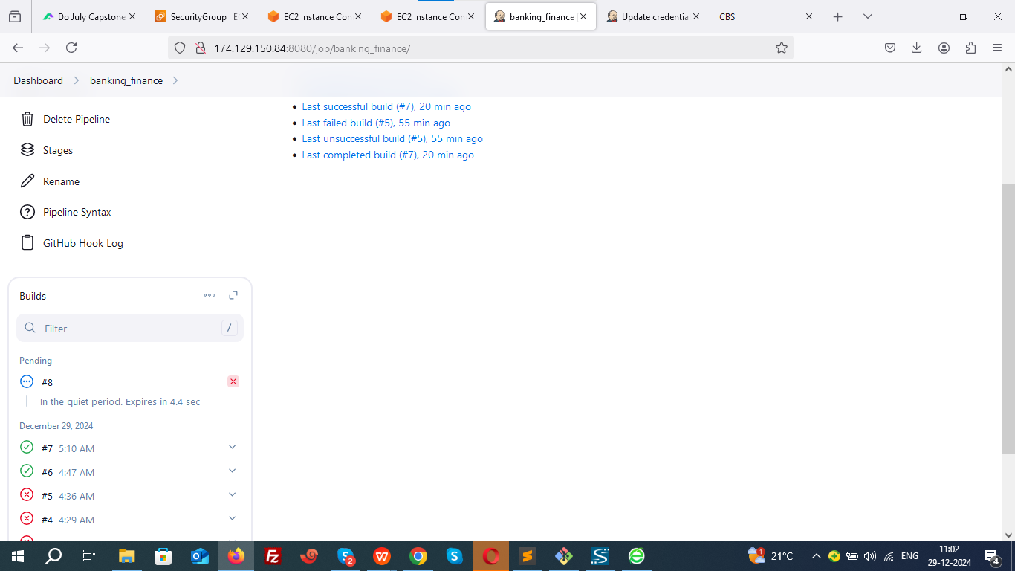

Build 8 is success

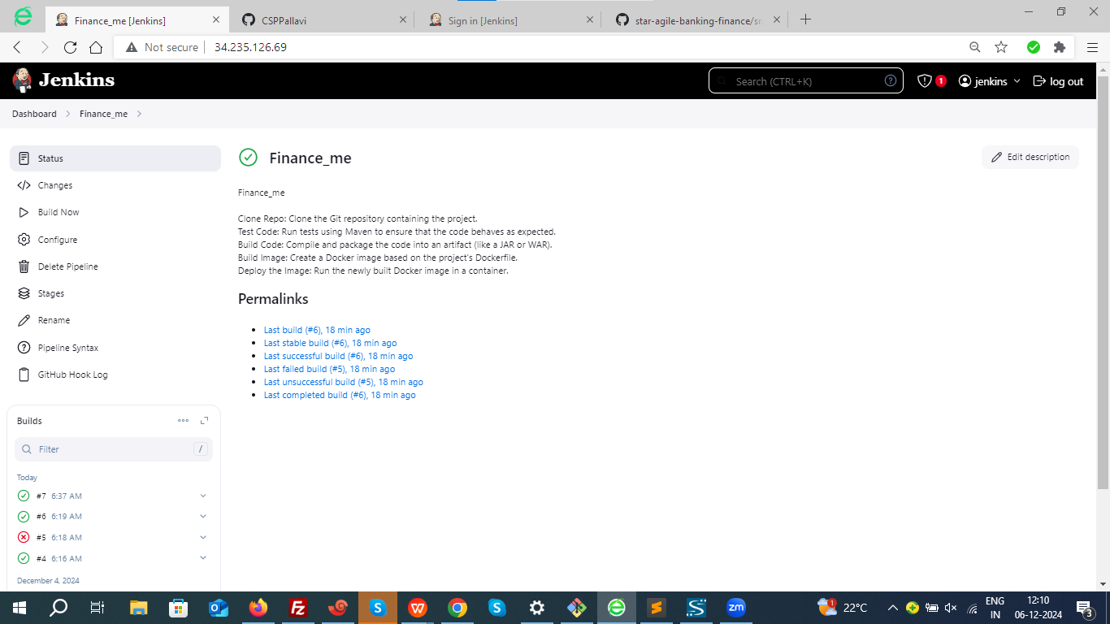

Verify the Github hook logs in Jenkins.

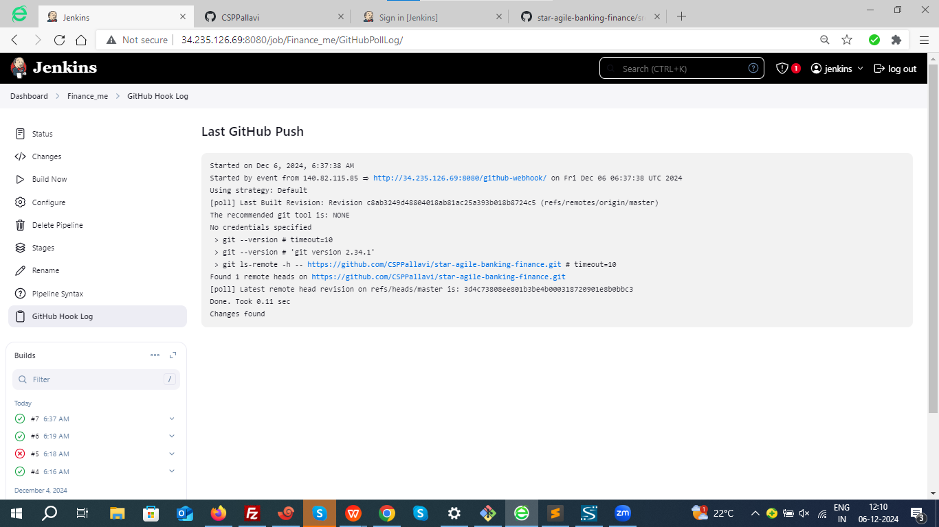

Verify the application to ensure changes has been occurred.



### ****Step 5: Setup Monitoring with Prometheus and Grafana****

#### ****Prometheus Setup****

#### ****Step 1: Download the Latest Prometheus****

Go to [Prometheus Releases](https://github.com/prometheus/prometheus/releases" \t "_new) and get the latest version link.

Replace <version> with the appropriate version.

wget <https://github.com/prometheus/prometheus/releases/latest/download/prometheus-<version>.linux-amd64.tar.gz>

wget <https://github.com/prometheus/prometheus/releases/download/v3.0.0/prometheus-3.0.0.linux-amd64.tar.gz>

#### ****Step 2: Extract the Archive****

tar -xvzf prometheus-<version>.linux-amd64.tar.gz

tar -xvzf prometheus-3.0.0.linux-amd64.tar.gz

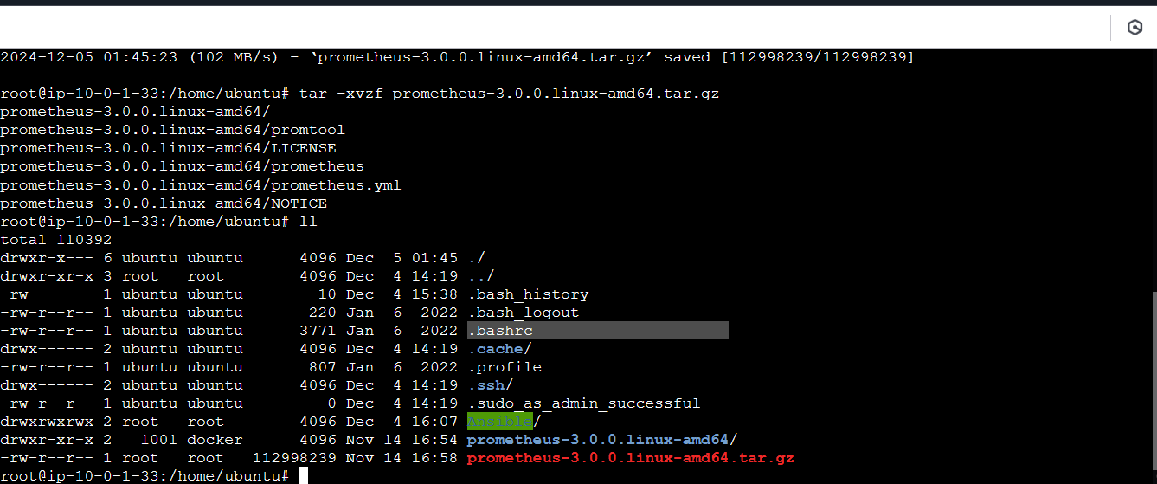

cd prometheus-<version>.linux-amd64/

cd prometheus-3.0.0.linux-amd64

#### ****Step 3: Move Files to Appropriate Directories****

sudo mv prometheus /usr/local/bin/

sudo mv promtool /usr/local/bin/

sudo mkdir -p /etc/prometheus /var/lib/prometheus

sudo mv prometheus.yml /etc/prometheus/

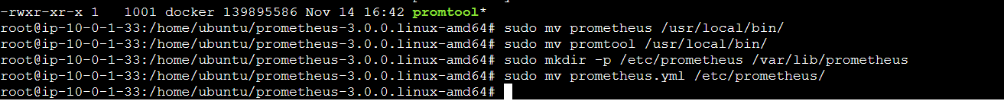

#### ****Step 4: Create Prometheus User****

sudo useradd --no-create-home --shell /usr/sbin/nologin prometheus

sudo chown -R prometheus:prometheus /etc/prometheus /var/lib/prometheus

sudo chown prometheus:prometheus /usr/local/bin/prometheus /usr/local/bin/promtool

#### ****Step 5: Set Up the Systemd Service****

sudo nano /etc/systemd/system/prometheus.service

Create the service file:

sudo nano /etc/systemd/system/prometheus.service

Paste the following configuration:

[Unit]

Description=Prometheus

Wants=network-online.target

After=network-online.target

[Service]

User=prometheus

Group=prometheus

Type=simple

ExecStart=/usr/local/bin/prometheus -- config.file=/etc/prometheus/prometheus.yml -- storage.tsdb.path=/var/lib/prometheus/ -- web.console.templates=/etc/prometheus/consoles -- web.console.libraries=/etc/prometheus/console\_libraries

Restart=always

[Install]

WantedBy=multi-user.target

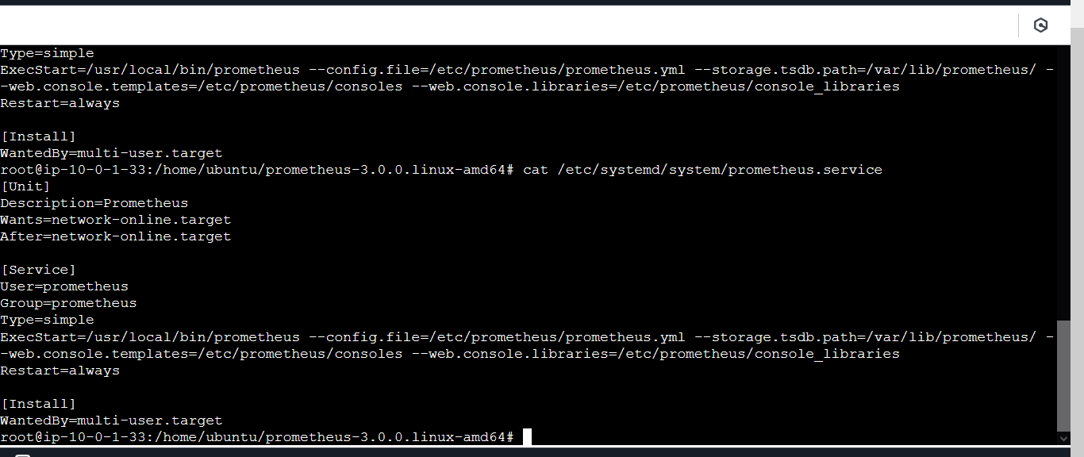

**Reload systemd and start Prometheus:**

sudo systemctl daemon-reload

sudo systemctl enable prometheus

sudo systemctl start prometheus

### ****5. Verify the Installation****

sudo systemctl status prometheus

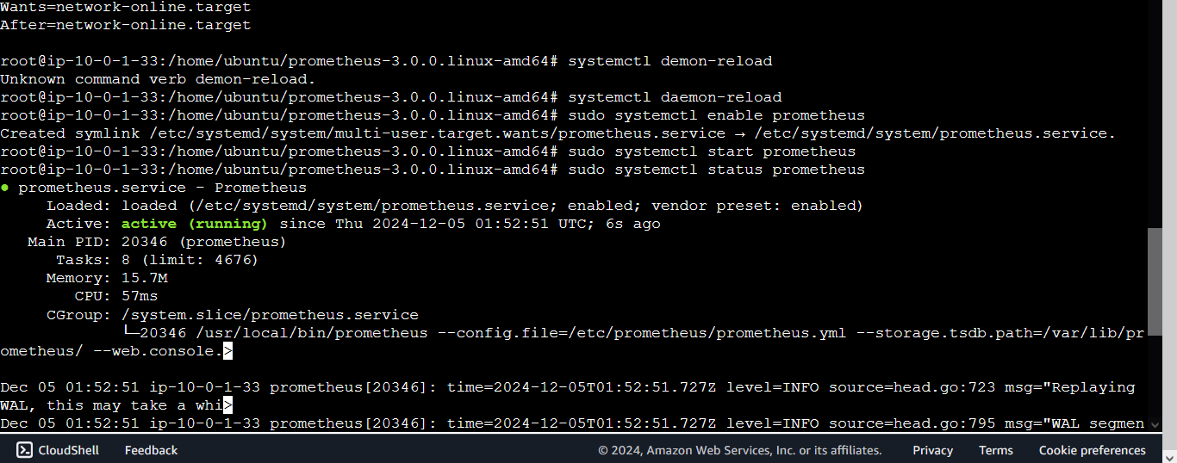

Check Prometheus at http://<server-ip>:9090 in your browser.

[http://34.235.126.69:9090](http://3.108.60.92:9090)

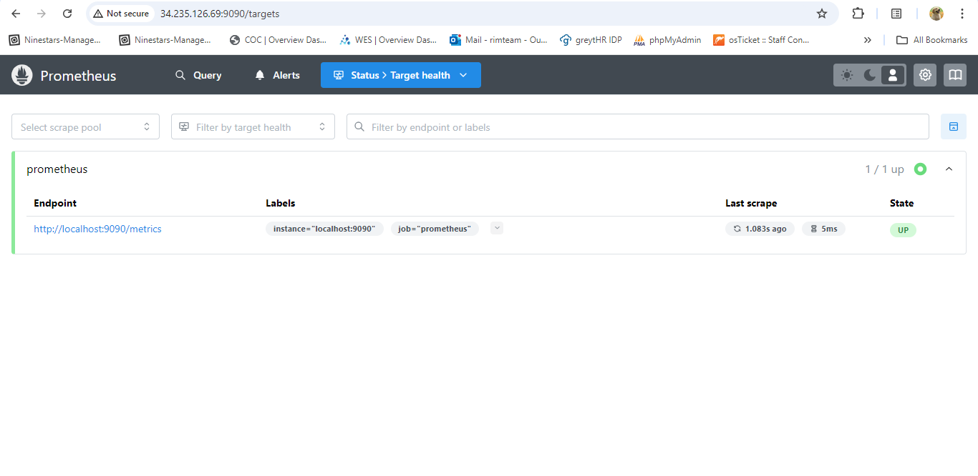

#### ****Node ExporterSetup****

### ****1. Download Node Exporter****

**Get the latest release of Node Exporter:** Visit the [Node Exporter GitHub Releases page](https://github.com/prometheus/node_exporter/releases" \t "_new) to find the latest version.

**Download the latest Node Exporter tarball:** Replace <version> with the desired version (e.g., 1.6.1).

wget <https://github.com/prometheus/node_exporter/releases/download/v<version>/node_exporter-<version>.linux-amd64.tar.gz>

wget <https://github.com/prometheus/node_exporter/releases/download/v1.8.2/node_exporter-1.8.2.linux-amd64.tar.gz>

**Extract the tarball:**

tar -xvzf node\_exporter-<version>.linux-amd64.tar.gz

tar -xvzf node\_exporter-1.8.2.linux-amd64.tar.gz

**Move the binary to** /usr/local/bin**:**

sudo mv node\_exporter-<version>.linux-amd64/node\_exporter /usr/local/bin/

mv node\_exporter /usr/local/bin/

### ****2. Create a Node Exporter User****

For security, create a dedicated user without shell access:

sudo useradd --no-create-home --shell /usr/sbin/nologin node\_exporter

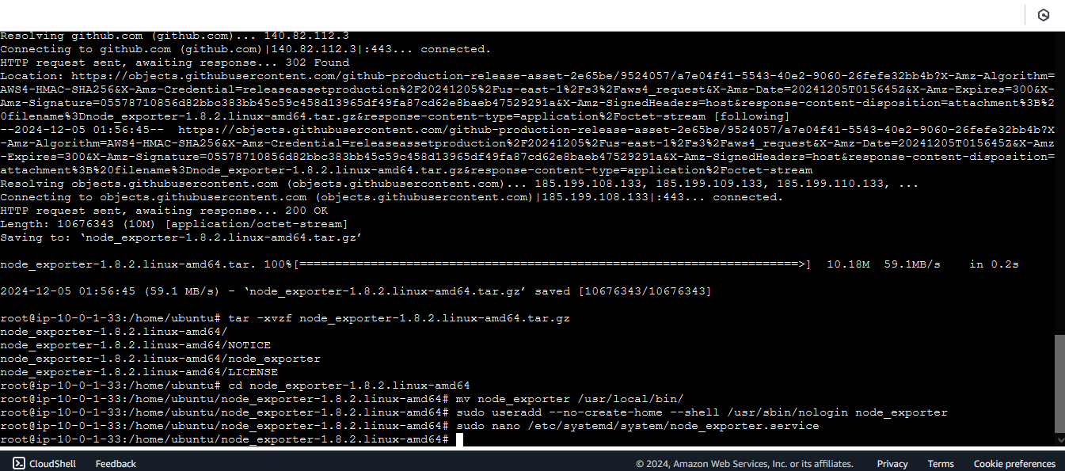

### ****3. Set Up a Systemd Service****

**Create a systemd service file for Node Exporter:**

sudo nano /etc/systemd/system/node\_exporter.service

**Add the following content:**

[Unit]

Description=Node Exporter

Wants=network-online.target

After=network-online.target

[Service]

User=node\_exporter

Group=node\_exporter

Type=simple

ExecStart=/usr/local/bin/node\_exporter

Restart=always

[Install]

WantedBy=multi-user.target

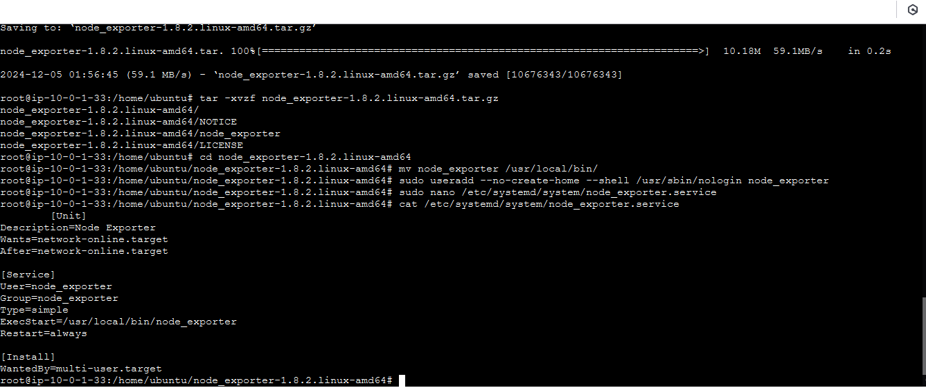

**Reload the systemd daemon:**

sudo systemctl daemon-reload

**Enable and start Node Exporter:**

sudo systemctl enable node\_exporter

sudo systemctl start node\_exporter

**Verify the service is running:**

sudo systemctl status node\_exporter

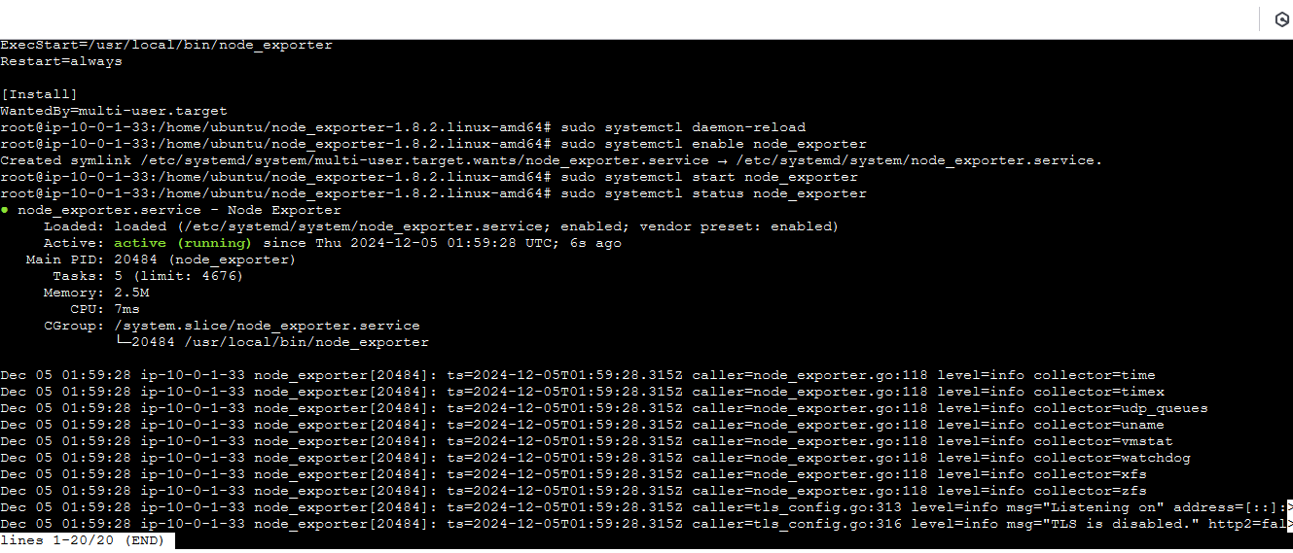

### ****4. Configure Prometheus to Scrape Node Exporter****

### ****Edit the Prometheus configuration file:****

sudo nano /etc/prometheus/prometheus.yml

**Add the Node Exporter job under** scrape\_configs**:**

- job\_name: 'node\_exporter'

scrape\_interval: 5s # Scrape this job every 5 seconds

static\_configs:

- targets: ['34.235.126.69:9100']

Replace <node\_exporter\_host> with the server's IP or hostname where Node Exporter is running.

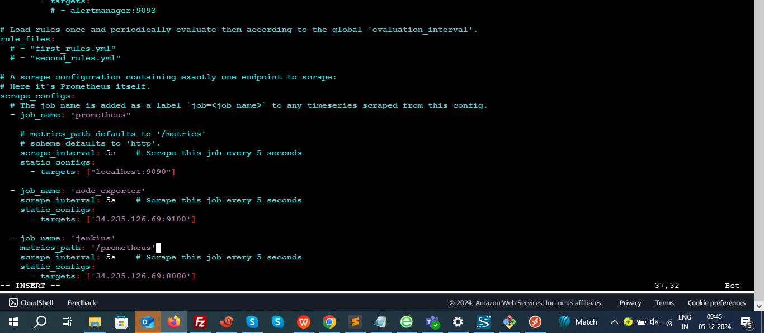

**Restart Prometheus:**

sudo systemctl restart prometheus

### ****5. Verify Node Exporter Integration****

**Access Node Exporter metrics:** Open your browser and visit:

<http://<server_ip>:9100/metrics>

<http://34.235.126.69:9100>

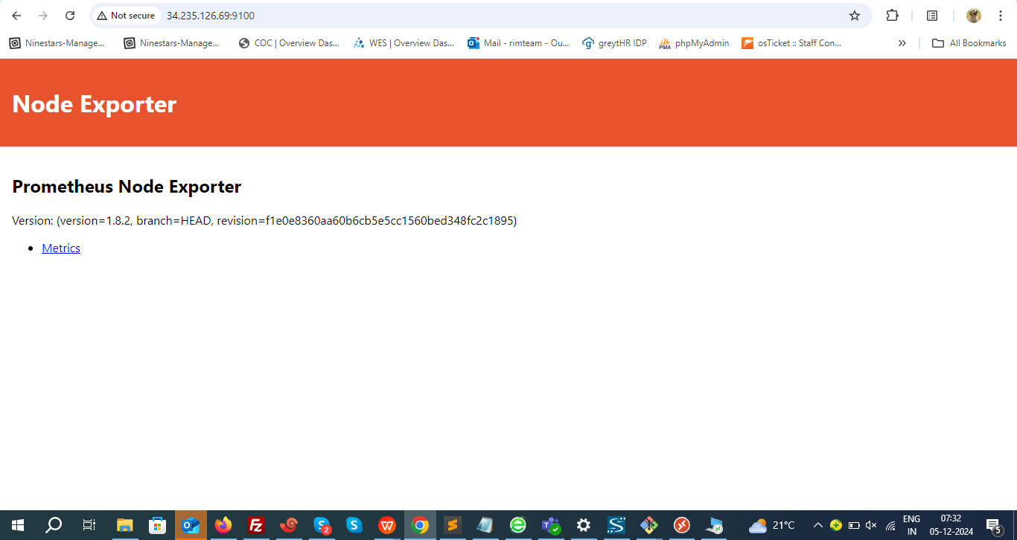

**Check node exporter setup in Prometheus:**

Open Prometheus at http://<prometheus\_ip>:9090, go to **Status > Targets**, and ensure the Node Exporter job is listed and up.

<http://34.235.126.69:9090/targets>

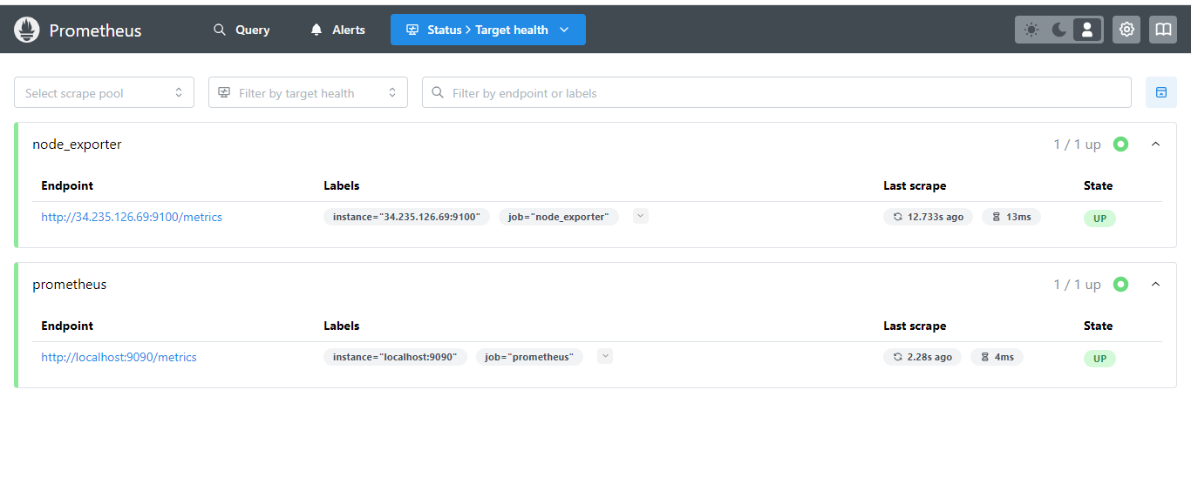

This setup ensures Node Exporter is installed, runs securely, and integrates with Prometheus.

Grafana installation:

### Step 1: Download and Add the Grafana GPG Key

1. Open your terminal.

Download the Grafana GPG key and add it to your APT keyring:

wget -q -O - https://packages.grafana.com/gpg.key | sudo apt-key add -

### Step 2: Add the Grafana Repository to APT Sources

Add the Grafana repository to your system’s APT sources:

sudo add-apt-repository "deb https://packages.grafana.com/oss/deb stable main"

### Step 3: Refresh the APT Cache

Update your package list to include the newly added Grafana repository:

sudo apt update

### Step 4: Install Grafana

Now, you can install Grafana by running:

sudo apt install grafana

### Step 5: Start the Grafana Server

Once Grafana is installed, start the Grafana service:

sudo systemctl start grafana-server

### Step 6: Verify Grafana is Running

Check the status of the Grafana service to ensure it is running properly:

sudo systemctl status grafana-server

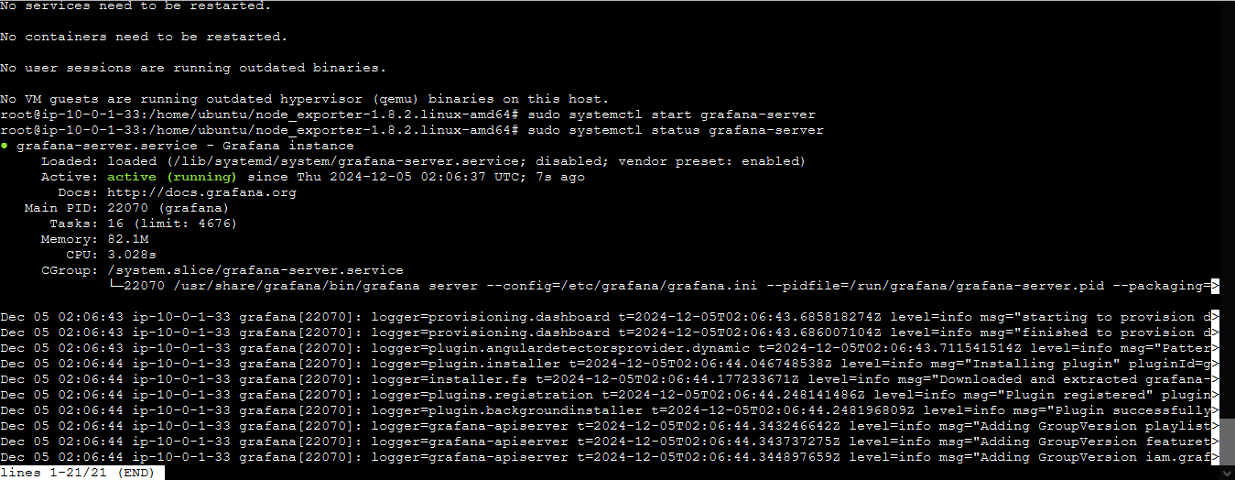

### Step 7: Enable Grafana to Start on Boot

To ensure Grafana starts automatically when the server boots up, run:

sudo systemctl enable grafana-server

### Step 8: Access Grafana in Browser

Open a web browser and navigate to:

<http://<instance_ip>:3000>

Replace <instance\_ip> with the IP address of your server.

<http://34.235.126.69:3000>

### 

### Step 9: Default Login Credentials

Use the default login credentials:

**Username**: admin

**Password**: admin

Once logged in, you will be prompted to change the default password.

That’s it! You should now have Grafana installed and accessible on your Ubuntu machine.

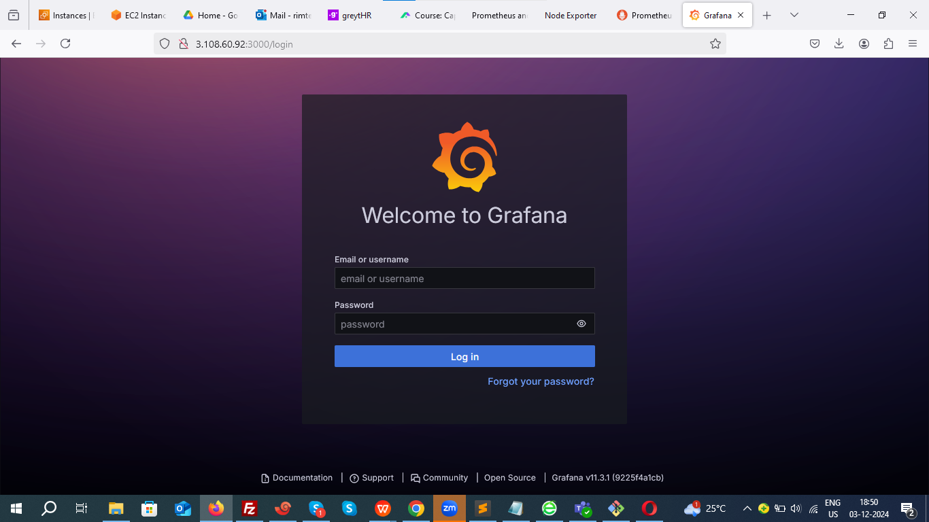

1. **Install prometheus plugin in Jenkins dashboard:**

Setup dashboard → install prometheus plugin -> restart Jenkins

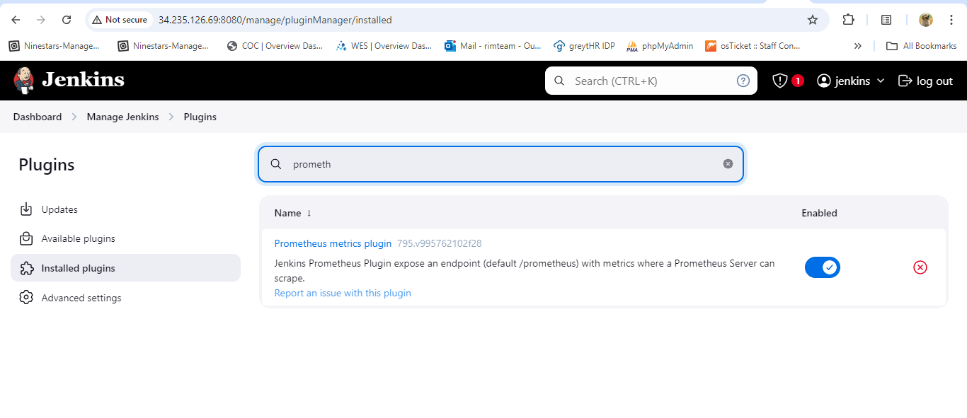

1. **Ensure Prometheus is Monitoring Jenkins.**

Go to prometheus.yaml file and paste below content.

sudo vim /etc/prometheus/prometheus.yml

- job\_name: 'jenkins'

metrics\_path: '/prometheus'

scrape\_interval: 5s # Scrape this job every 5 seconds

static\_configs:

- targets: ['34.235.126.69:8080']



1. **Restart prometheus**

After changes in config file we need to restart prometheus

sudo systemctl restart prometheus

**Check whether Jenkins is added to target health in Prometheus.**

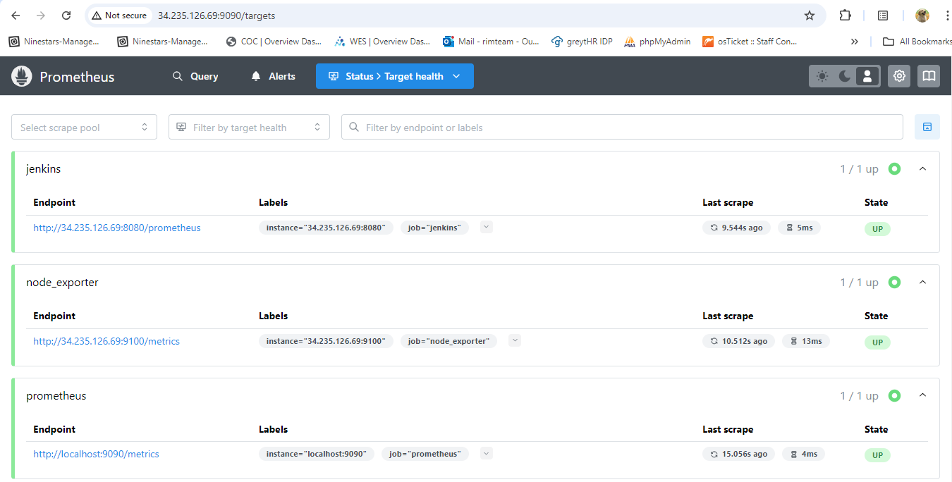

**Setting up Grafana Dashboard:**

### ****Step 1: Add Prometheus as a Data Source in Grafana****

1. Navigate to Home **> Connections** in Grafana.
2. Click **Add data source** and select **Prometheus**.

Add prometheus server url: <http://34.235.126.69:9090>

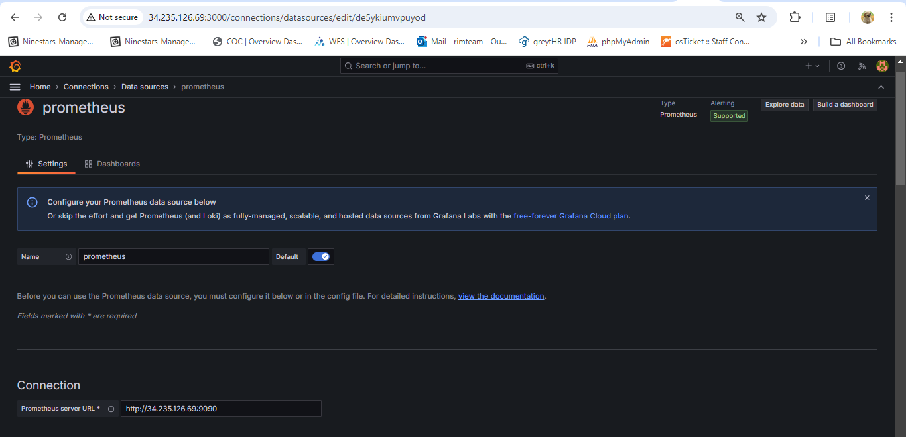

Save&Test

### ****Step 3: Create a New Dashboard****

1. In Grafana, click **+ > Dashboard > Add Visualization**

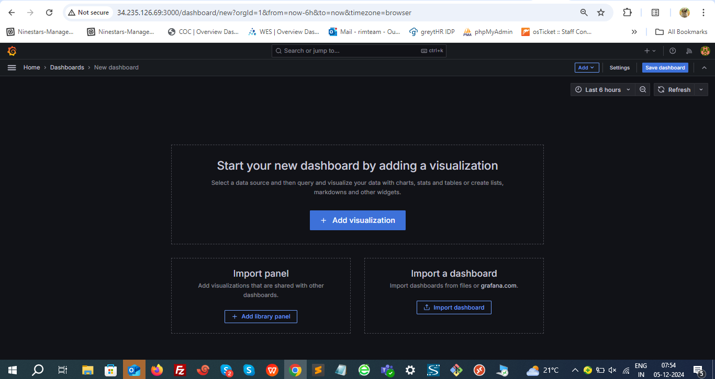

Select **Prometheus** as the data source.

### ****Step 4: Add Panels for CPU Utilization, Memory Utilization and Disk Space Utilization****

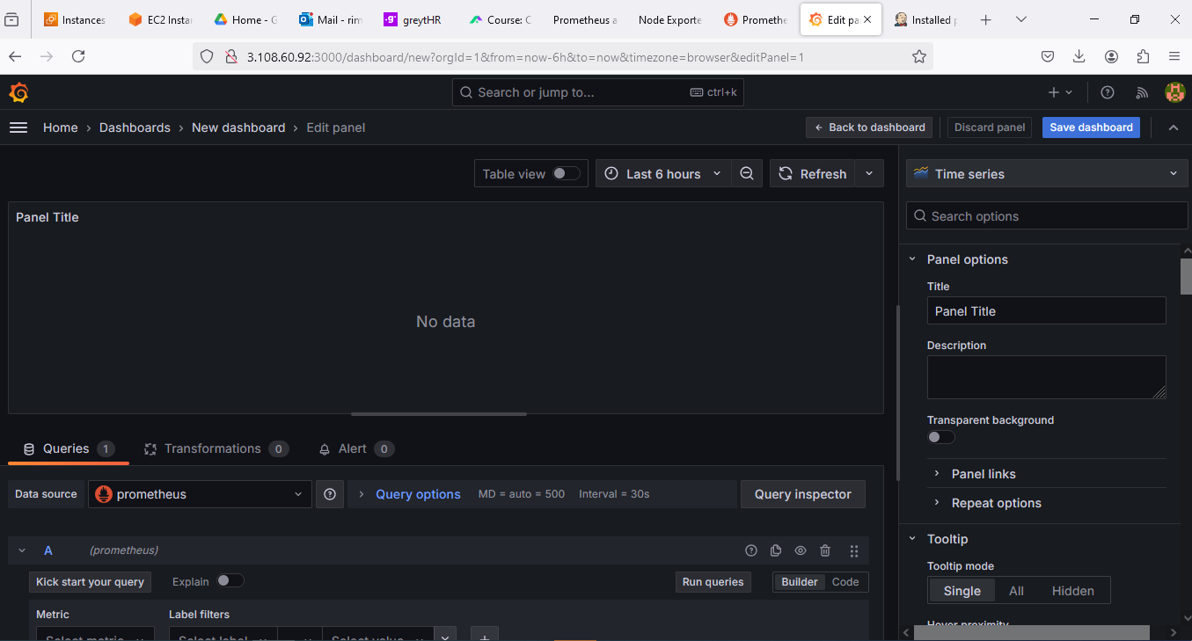

#### ****Panel 1: CPU UtilizationQuery****:

**PromQL Queries**

**Add below mentioned queries one after the other.**

**node\_load1**

**node\_load5**

**node\_load15**

**· 1-Minute Load Average: node\_load1**

**· 5-Minute Load Average: node\_load5**

**· 15-Minute Load Average: node\_load15**

**Visualization**:

Select **Time Series** or **Gauge** based on your preference..

**Title**: Name it **"CPU Utilization"**.

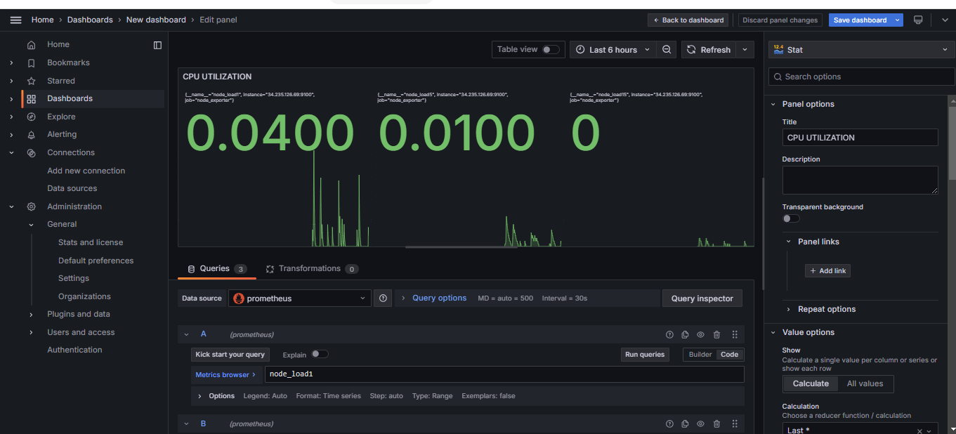

Save the Dashboard as Jenkins dashboard.

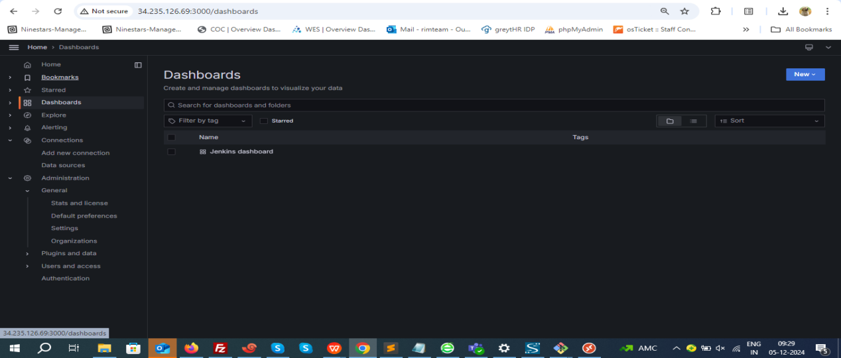

#### ****Panel 2: Memory Utilization****

**PromQL Queries for Memory Metrics**

1. **Total Memory (MiB):**

**node\_memory\_MemTotal\_bytes / 1024 / 1024**

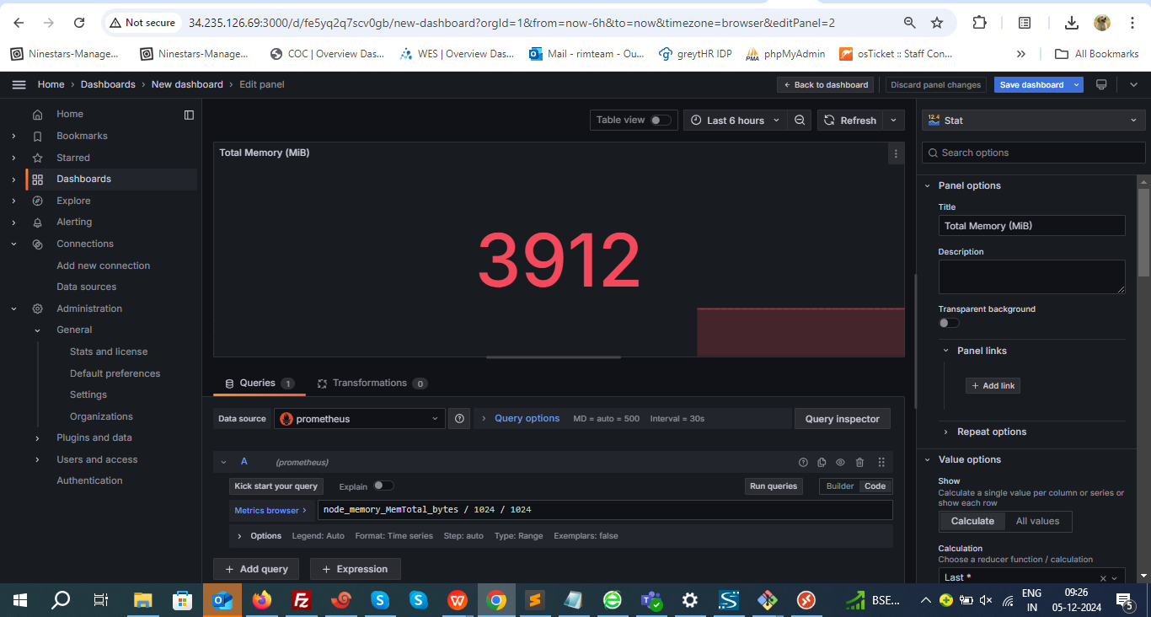

**This gives the total memory in MiB.**

1. **Free Memory (MiB):**

**node\_memory\_MemFree\_bytes / 1024 / 1024**

**This gives the free memory in MiB.**

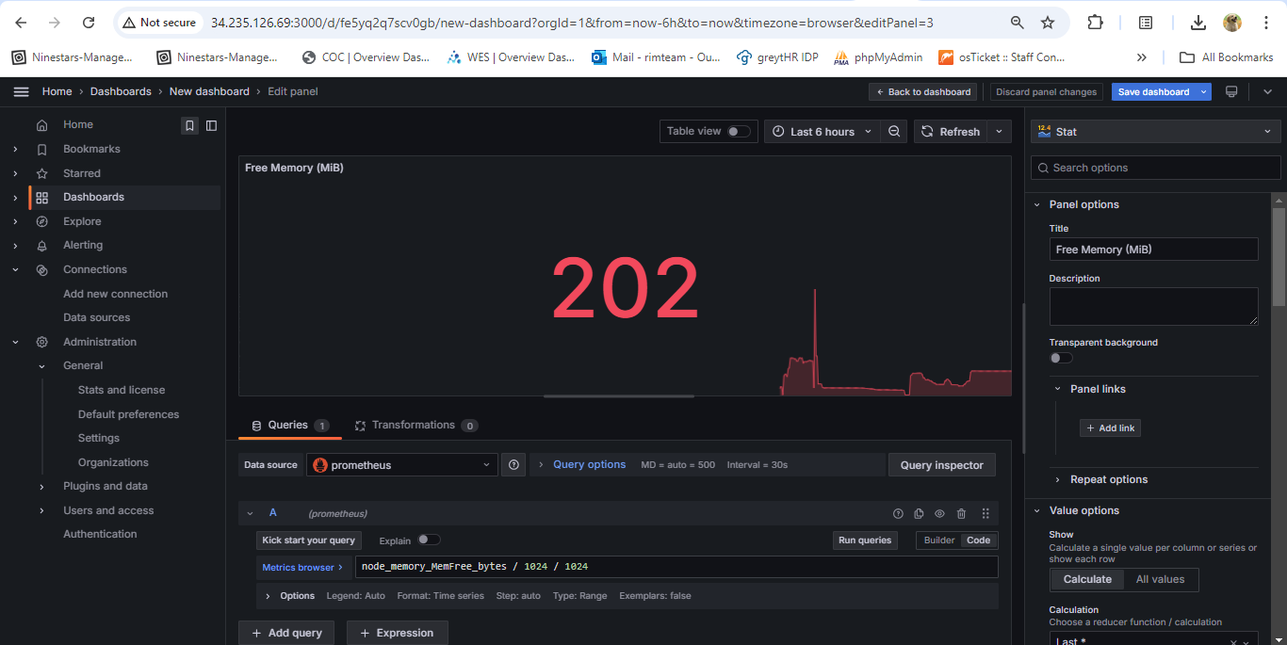

1. **Used Memory (MiB): Used memory can be calculated as:**

**(node\_memory\_MemTotal\_bytes - node\_memory\_MemFree\_bytes - node\_memory\_Cached\_bytes - node\_memory\_Buffers\_bytes) / 1024 / 1024**

**This excludes the memory used for cache and buffers.**

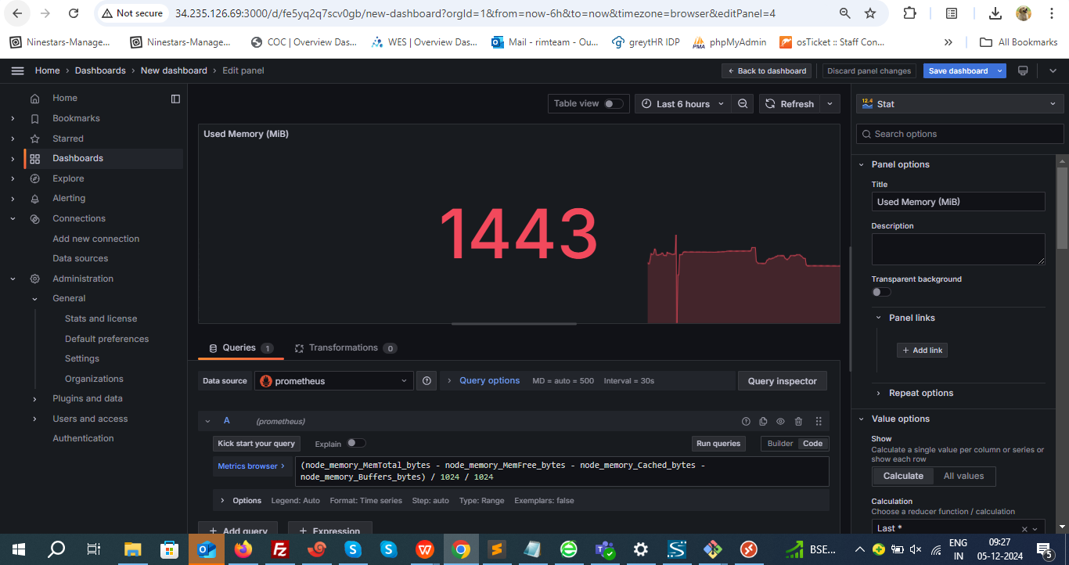

1. **Buffer/Cache Memory (MiB):**

**(node\_memory\_Cached\_bytes + node\_memory\_Buffers\_bytes) / 1024 / 1024**

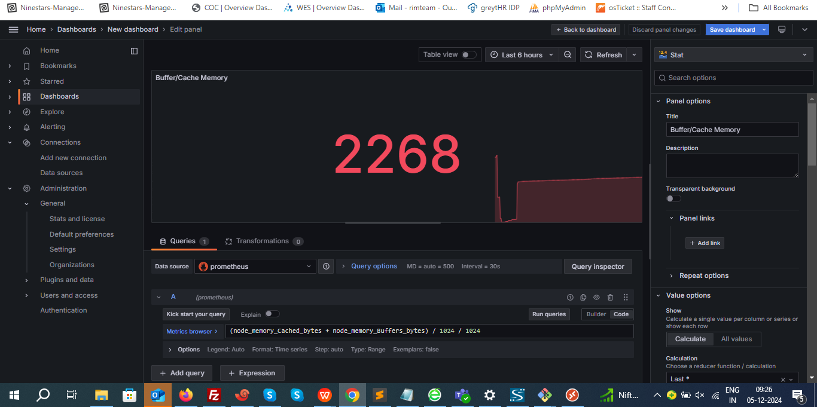

**Visualization**:

Use **Time Series** or **Gauge**.

**Title**: Name it **a**ccording to Memory Utilization**.**

#### ****Panel 3: Disk Space Utilization****

1. **Disk Space Usage (in GB):**

Query:

(node\_filesystem\_size\_bytes{mountpoint="/"} - node\_filesystem\_free\_bytes{mountpoint="/"}) / (1024^3)

Visualization: Gauge or Time series to display the disk space usage percentage.

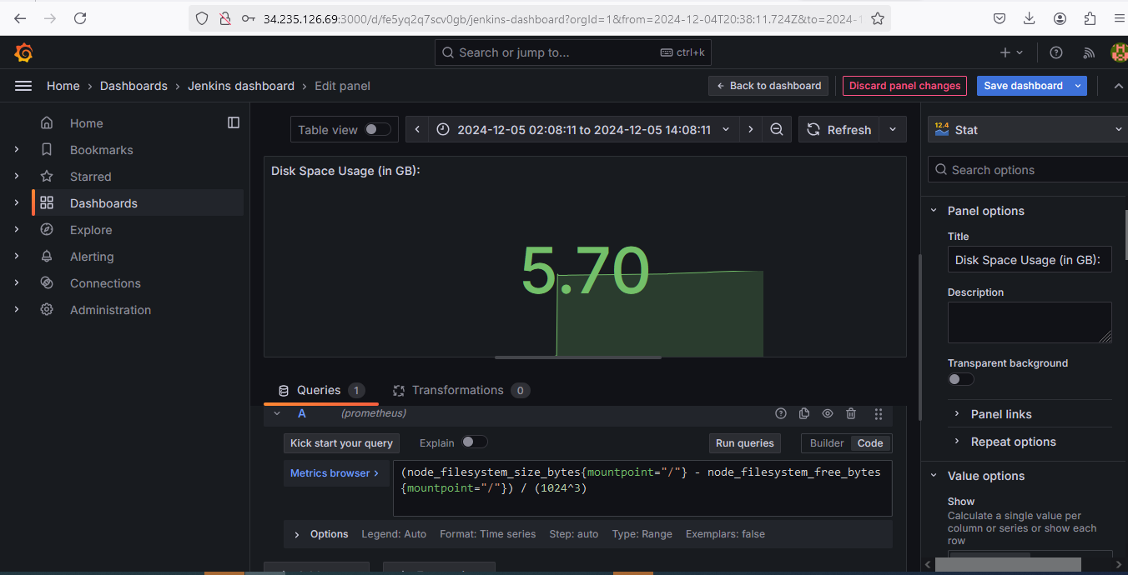

**2. Total Disk Space (in GB):**

Query:

node\_filesystem\_size\_bytes{mountpoint="/"} / 1024 / 1024 / 1024

Visualization: Stat to show the total size.

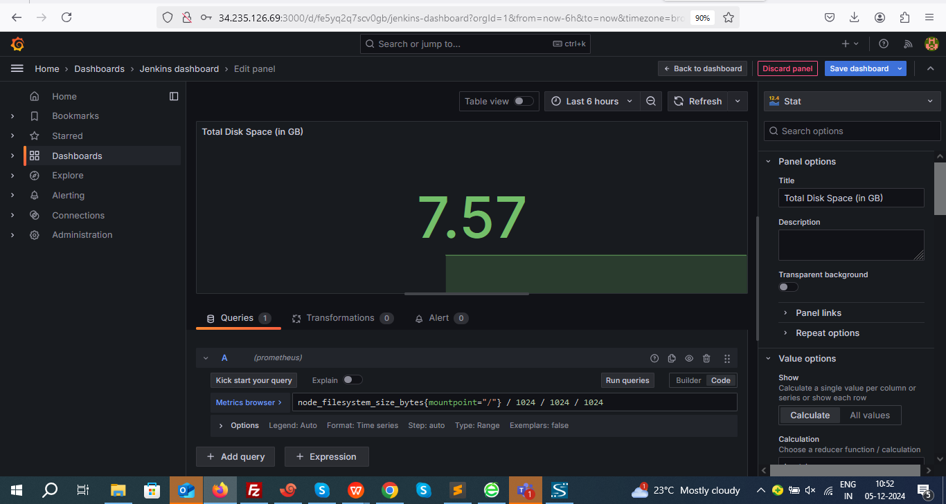

**3.Free Disk Space (in GB):**

Query:

node\_filesystem\_free\_bytes{mountpoint="/"} / 1024 / 1024 / 1024

Visualization: Stat or Bar gauge to show the amount of free space.

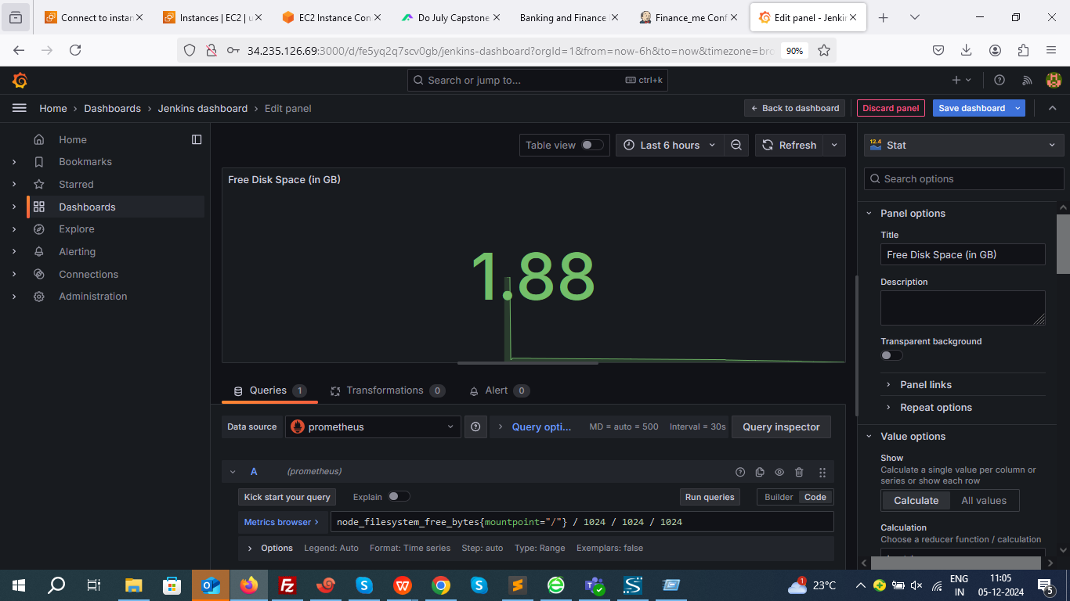

**4. Available Disk Space(in GB):**

Query:

node\_filesystem\_avail\_bytes{mountpoint="/"} / 1024 / 1024 / 1024

Visualization: Stat or Gauge to show available space for users.

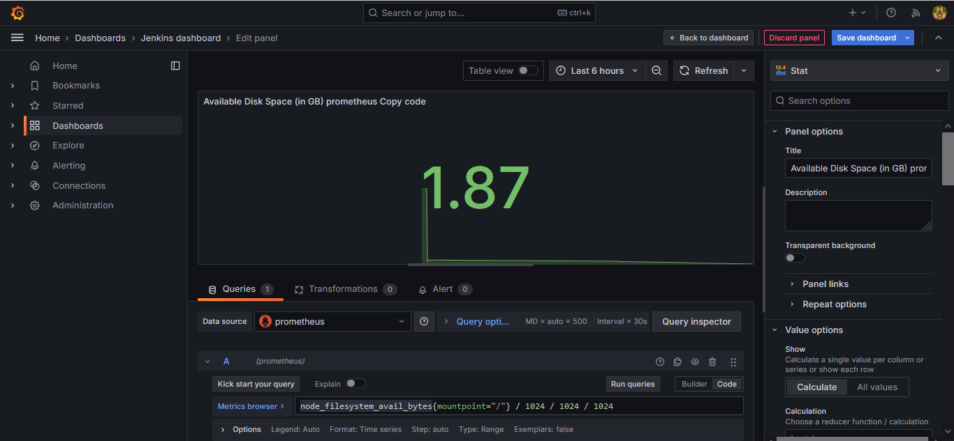

Comparing manually from server data

Filesystem Size Used Avail Use% Mounted on

/dev/root 7.6G 5.7G 1.9G 76% /

Customize the visualizations and titles accordingly.

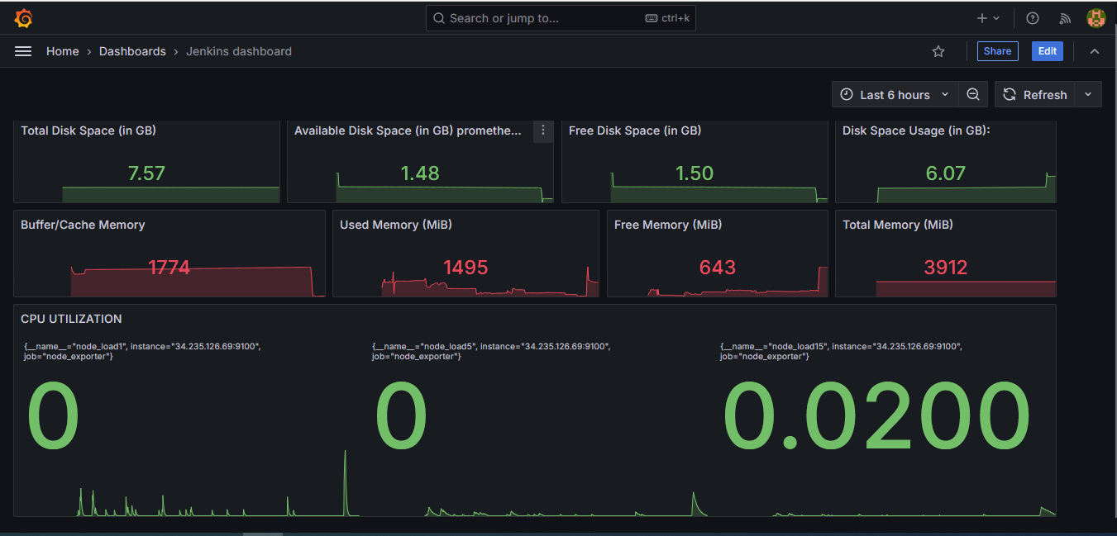

**CONCLUSION:**

The application is successfully deployed and theinfrastructure is now fully automated and continuously monitored.